**Topic: ZAGI Data-Base**

**Assignment-5.1.4- Queries**

**University of Colorado Denver**



**Submitted to**

**Professor: Dr. Mohamad Saleh**

**Submitted By**

**Sai Lokesh Siddanathi**

***(1)****For the relation PRODUCT, show the columns ProductID and   
 ProductPrice and a column showing ProductPrice increased by   
 10%*

***SELECT Product_id,Price, (Price * 1.1) AS IncreasedPrice***

***FROM PRODUCT;***

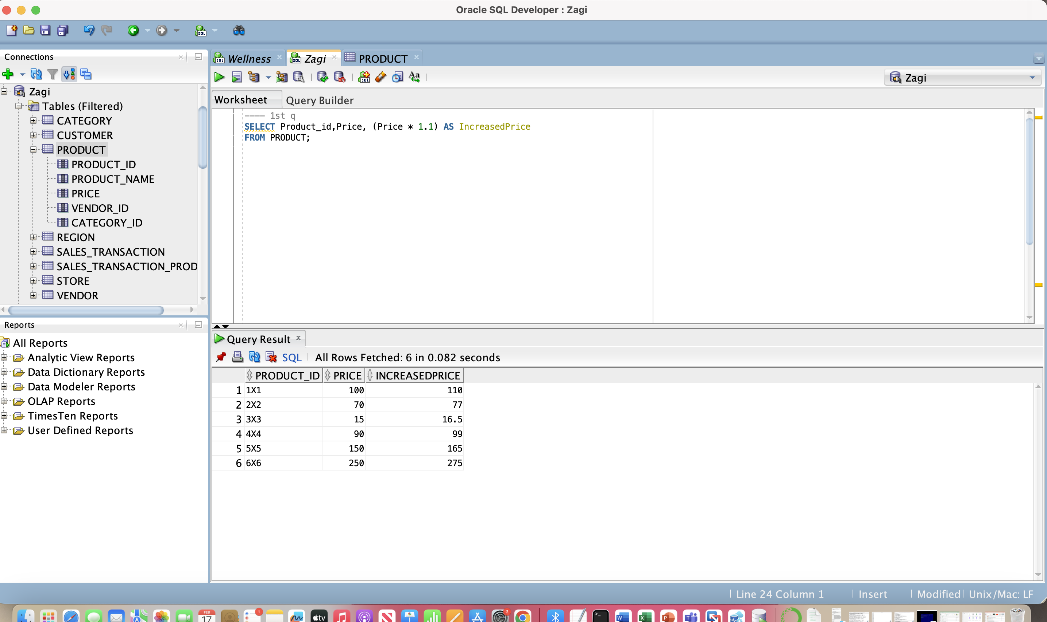

***(2)*** *Retrieve the product ID, product name, vendor ID, and   
 product price for each product whose price is above $100*

SELECT Product_id, Product_name, Vendor_id, Price

FROM Product

WHERE Price > 100;

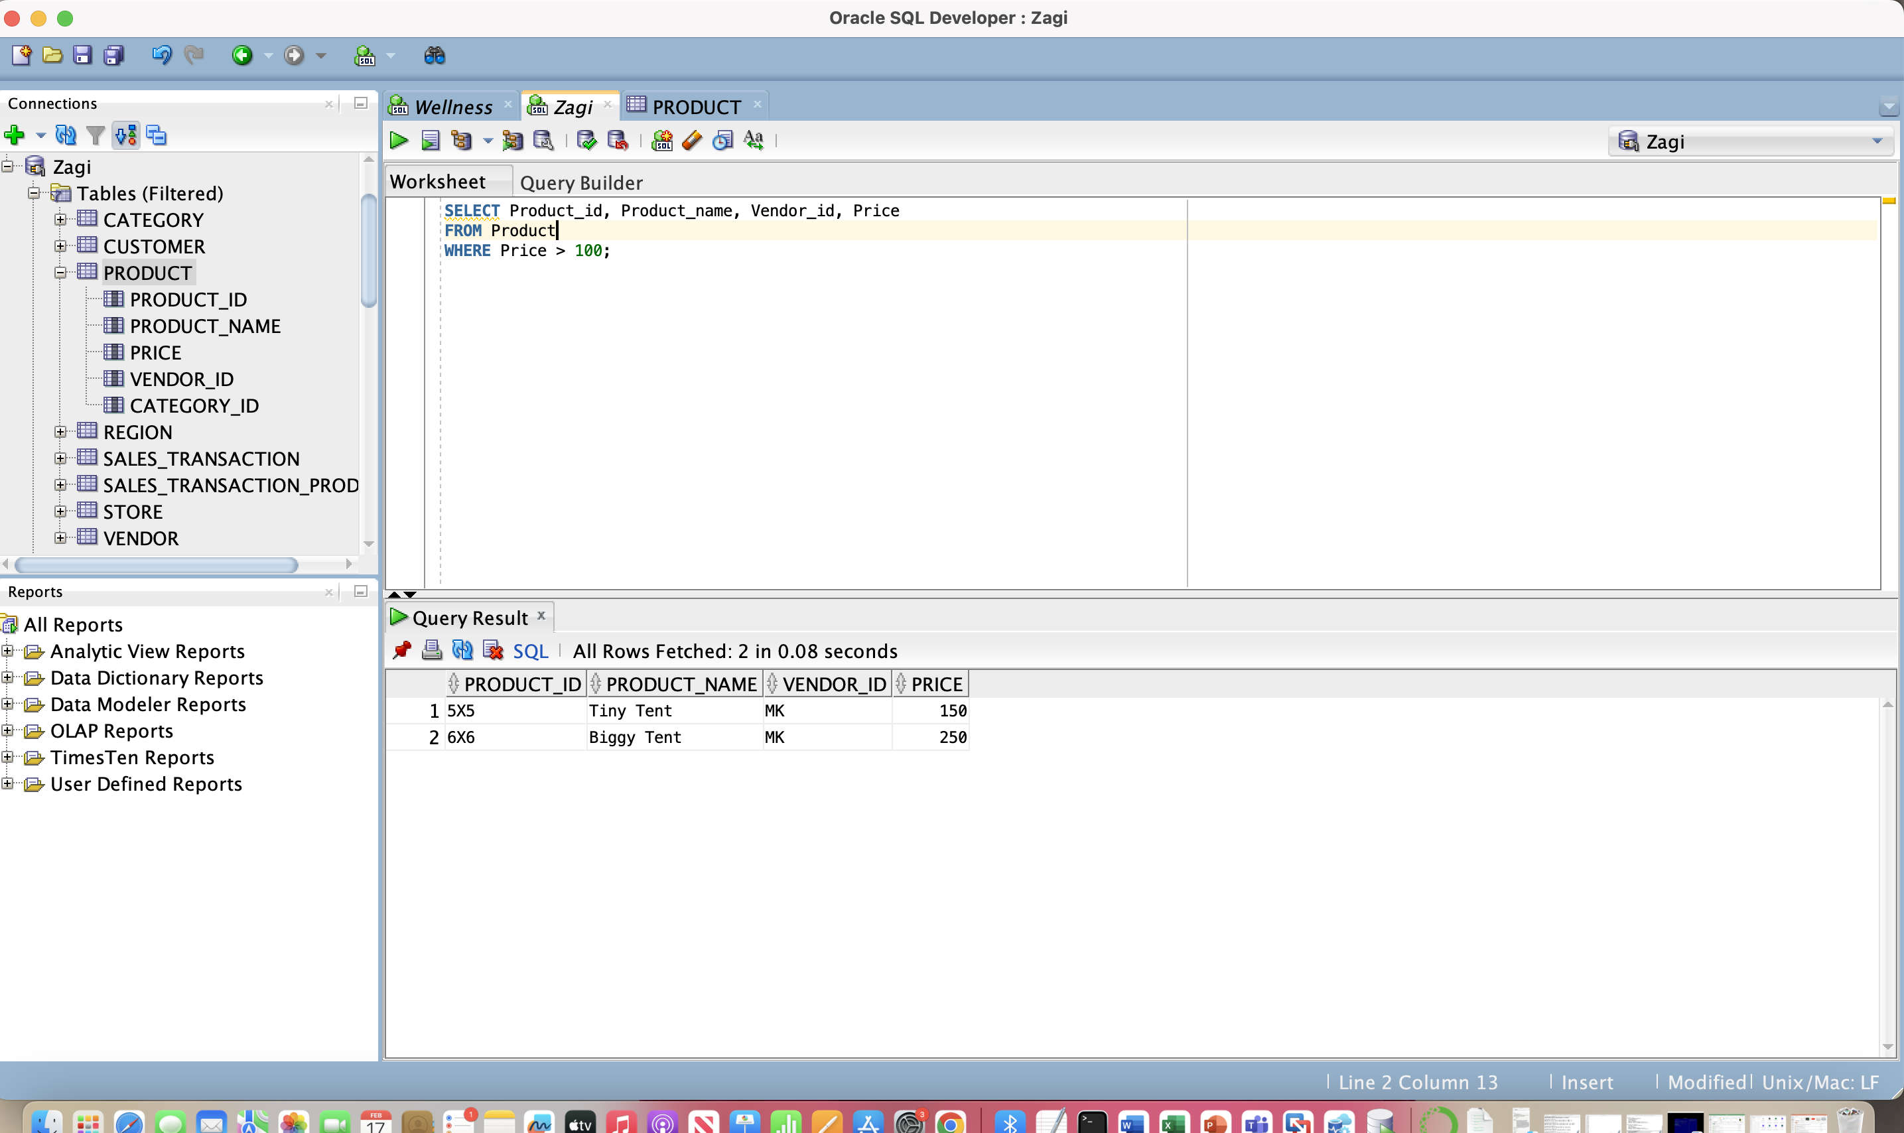

***(3)*** *Retrieve the product ID, product name, vendor ID, and   
 product price for each product in the FW category whose price  
 is equal to or below $110*

SELECT Product_id, Product_name, Vendor_id, Price

FROM Product

WHERE price <= 110 AND category_id= 'FW';

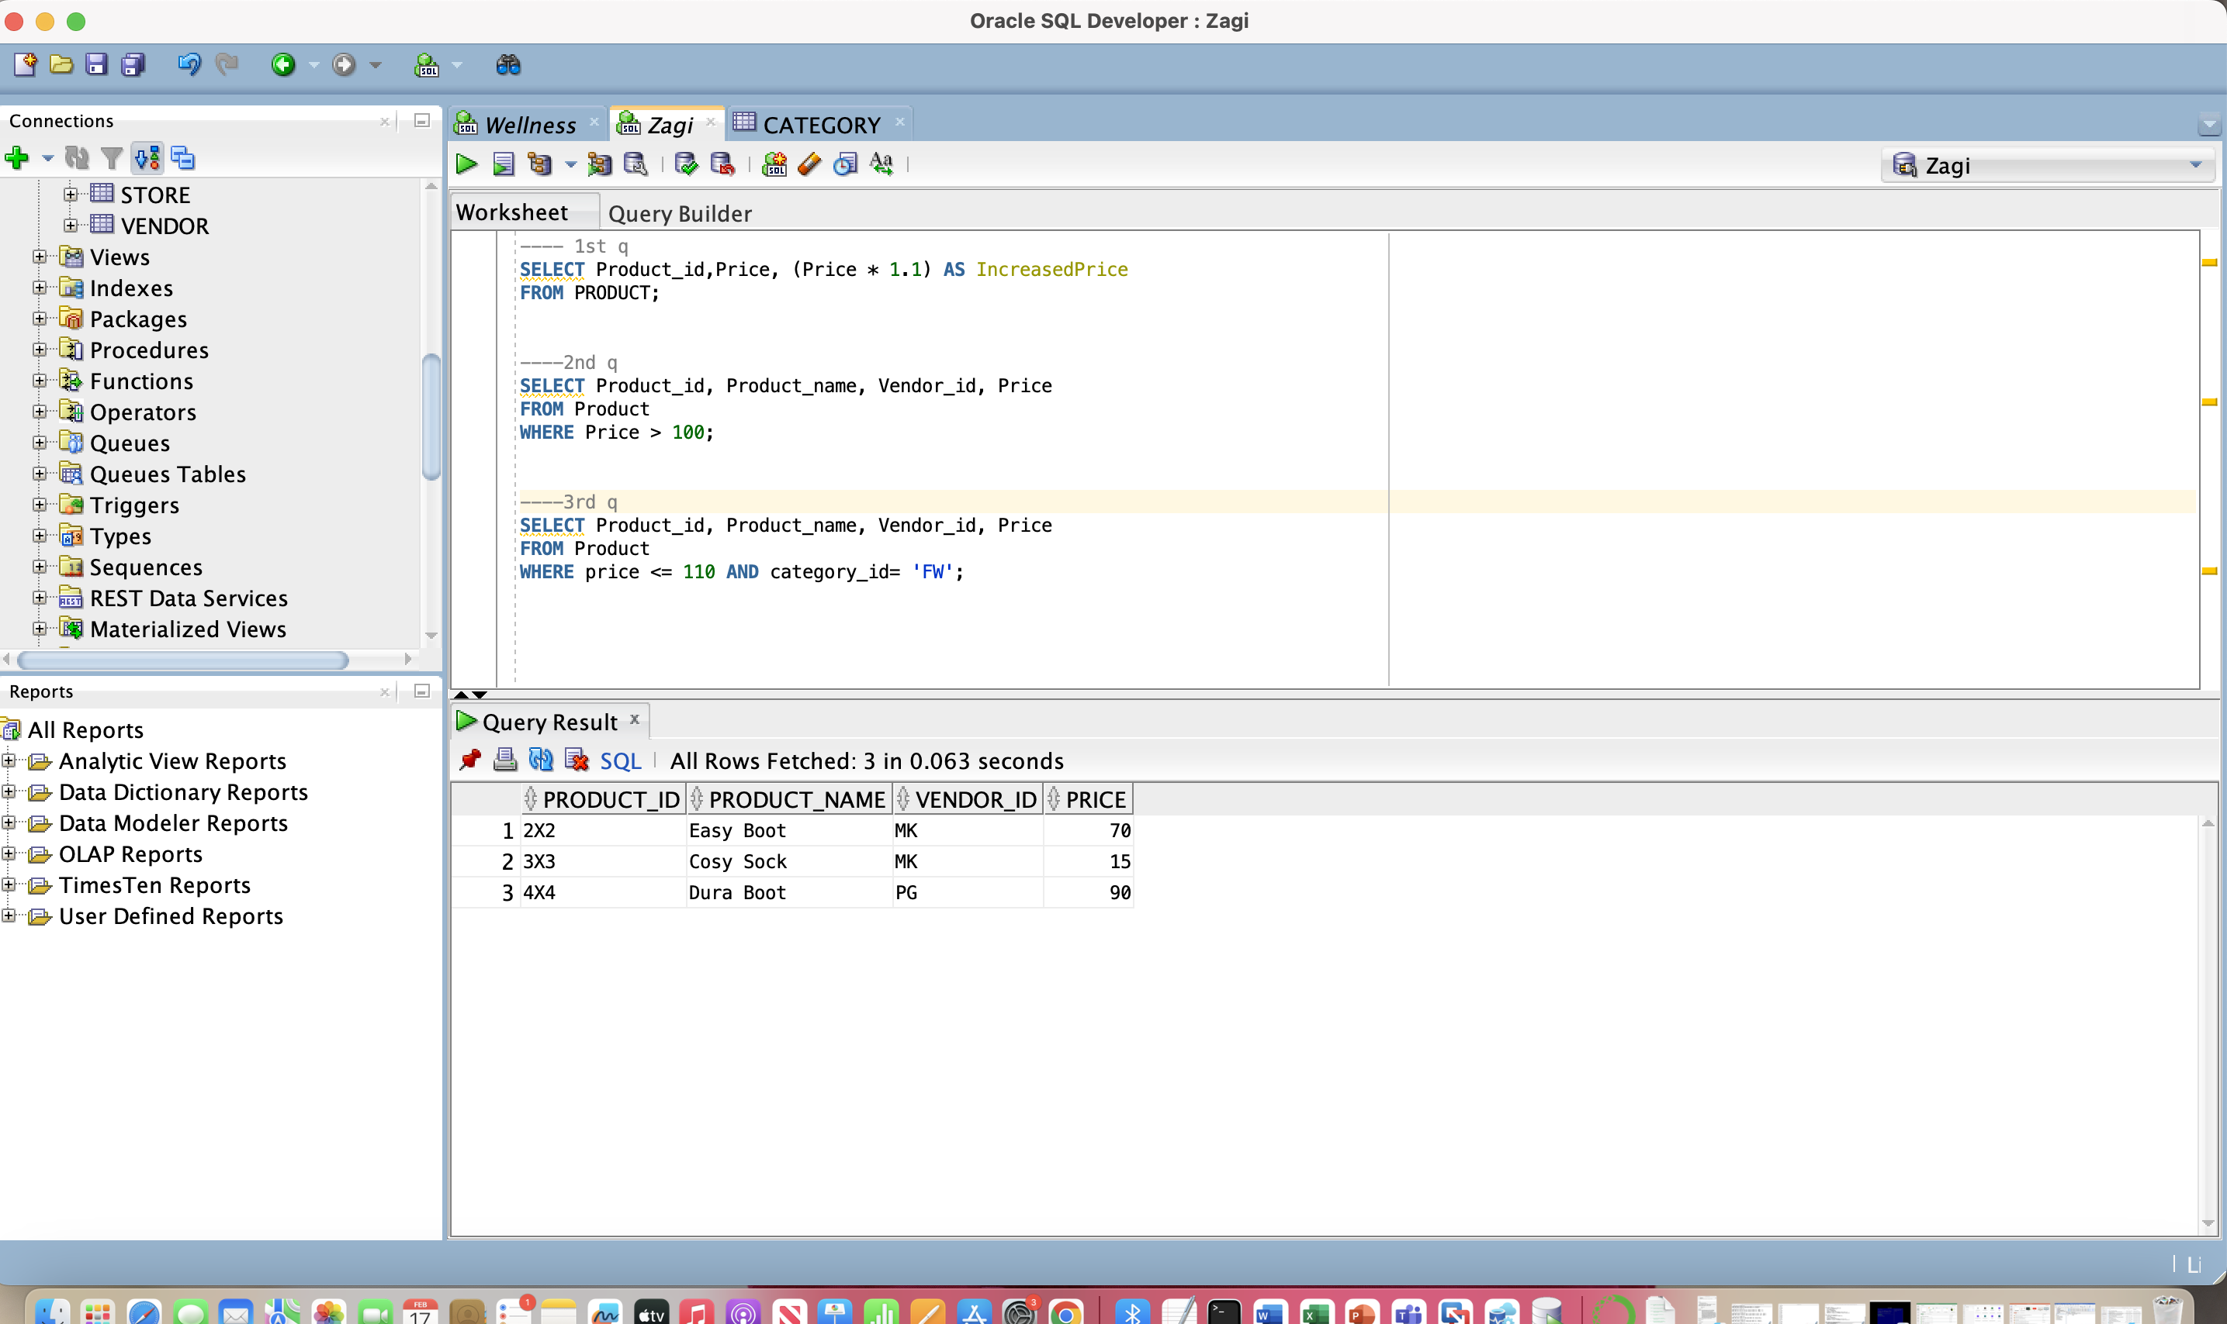

***(4)*** *Show one instance of all the different VendorID values in the   
 relation PRODUCT*

SELECT DISTINCT vendor_id

FROM PRODUCT;

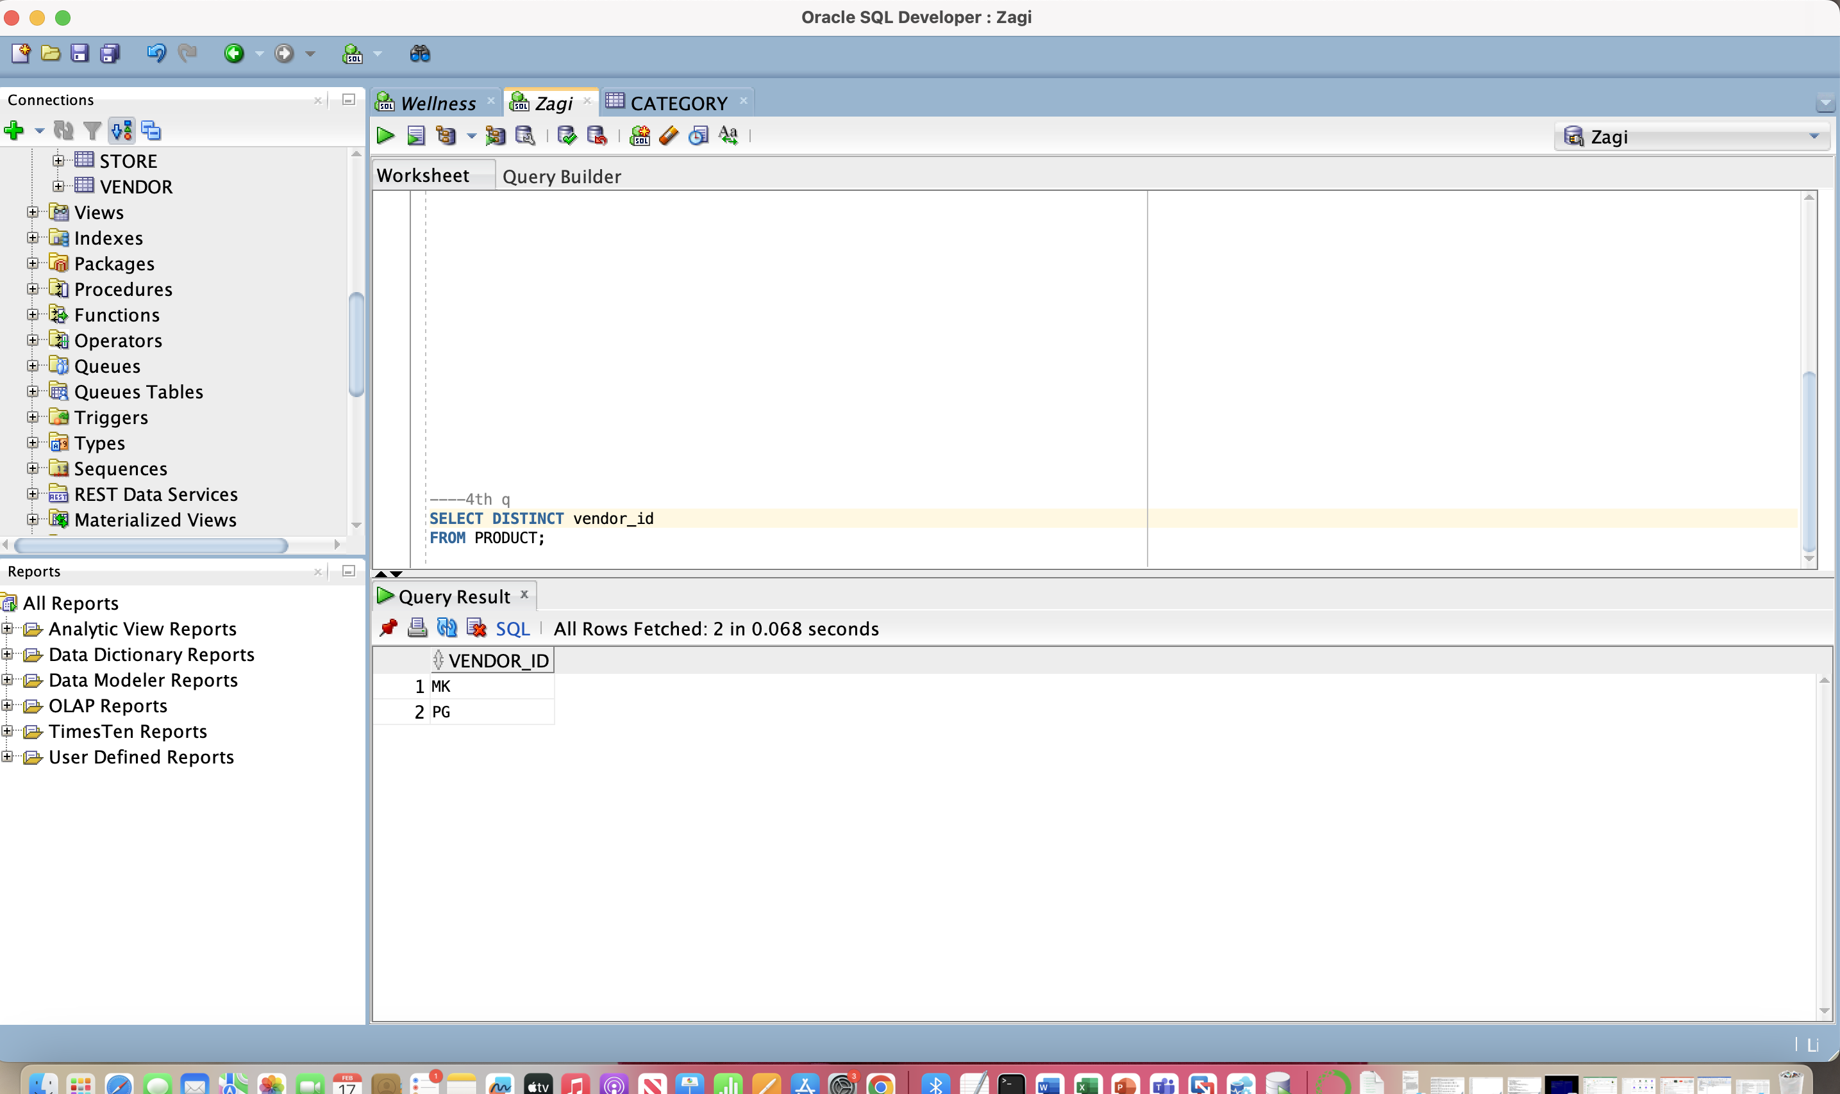

***(5)*** *Retrieve the product ID, product name, category ID, and   
 product price for each product in the FW product category,   
 sorted by product price*

*SELECT product_id, product_name, category_id, price*

*FROM product*

*WHERE category_id = 'FW'*

*ORDER BY price;*

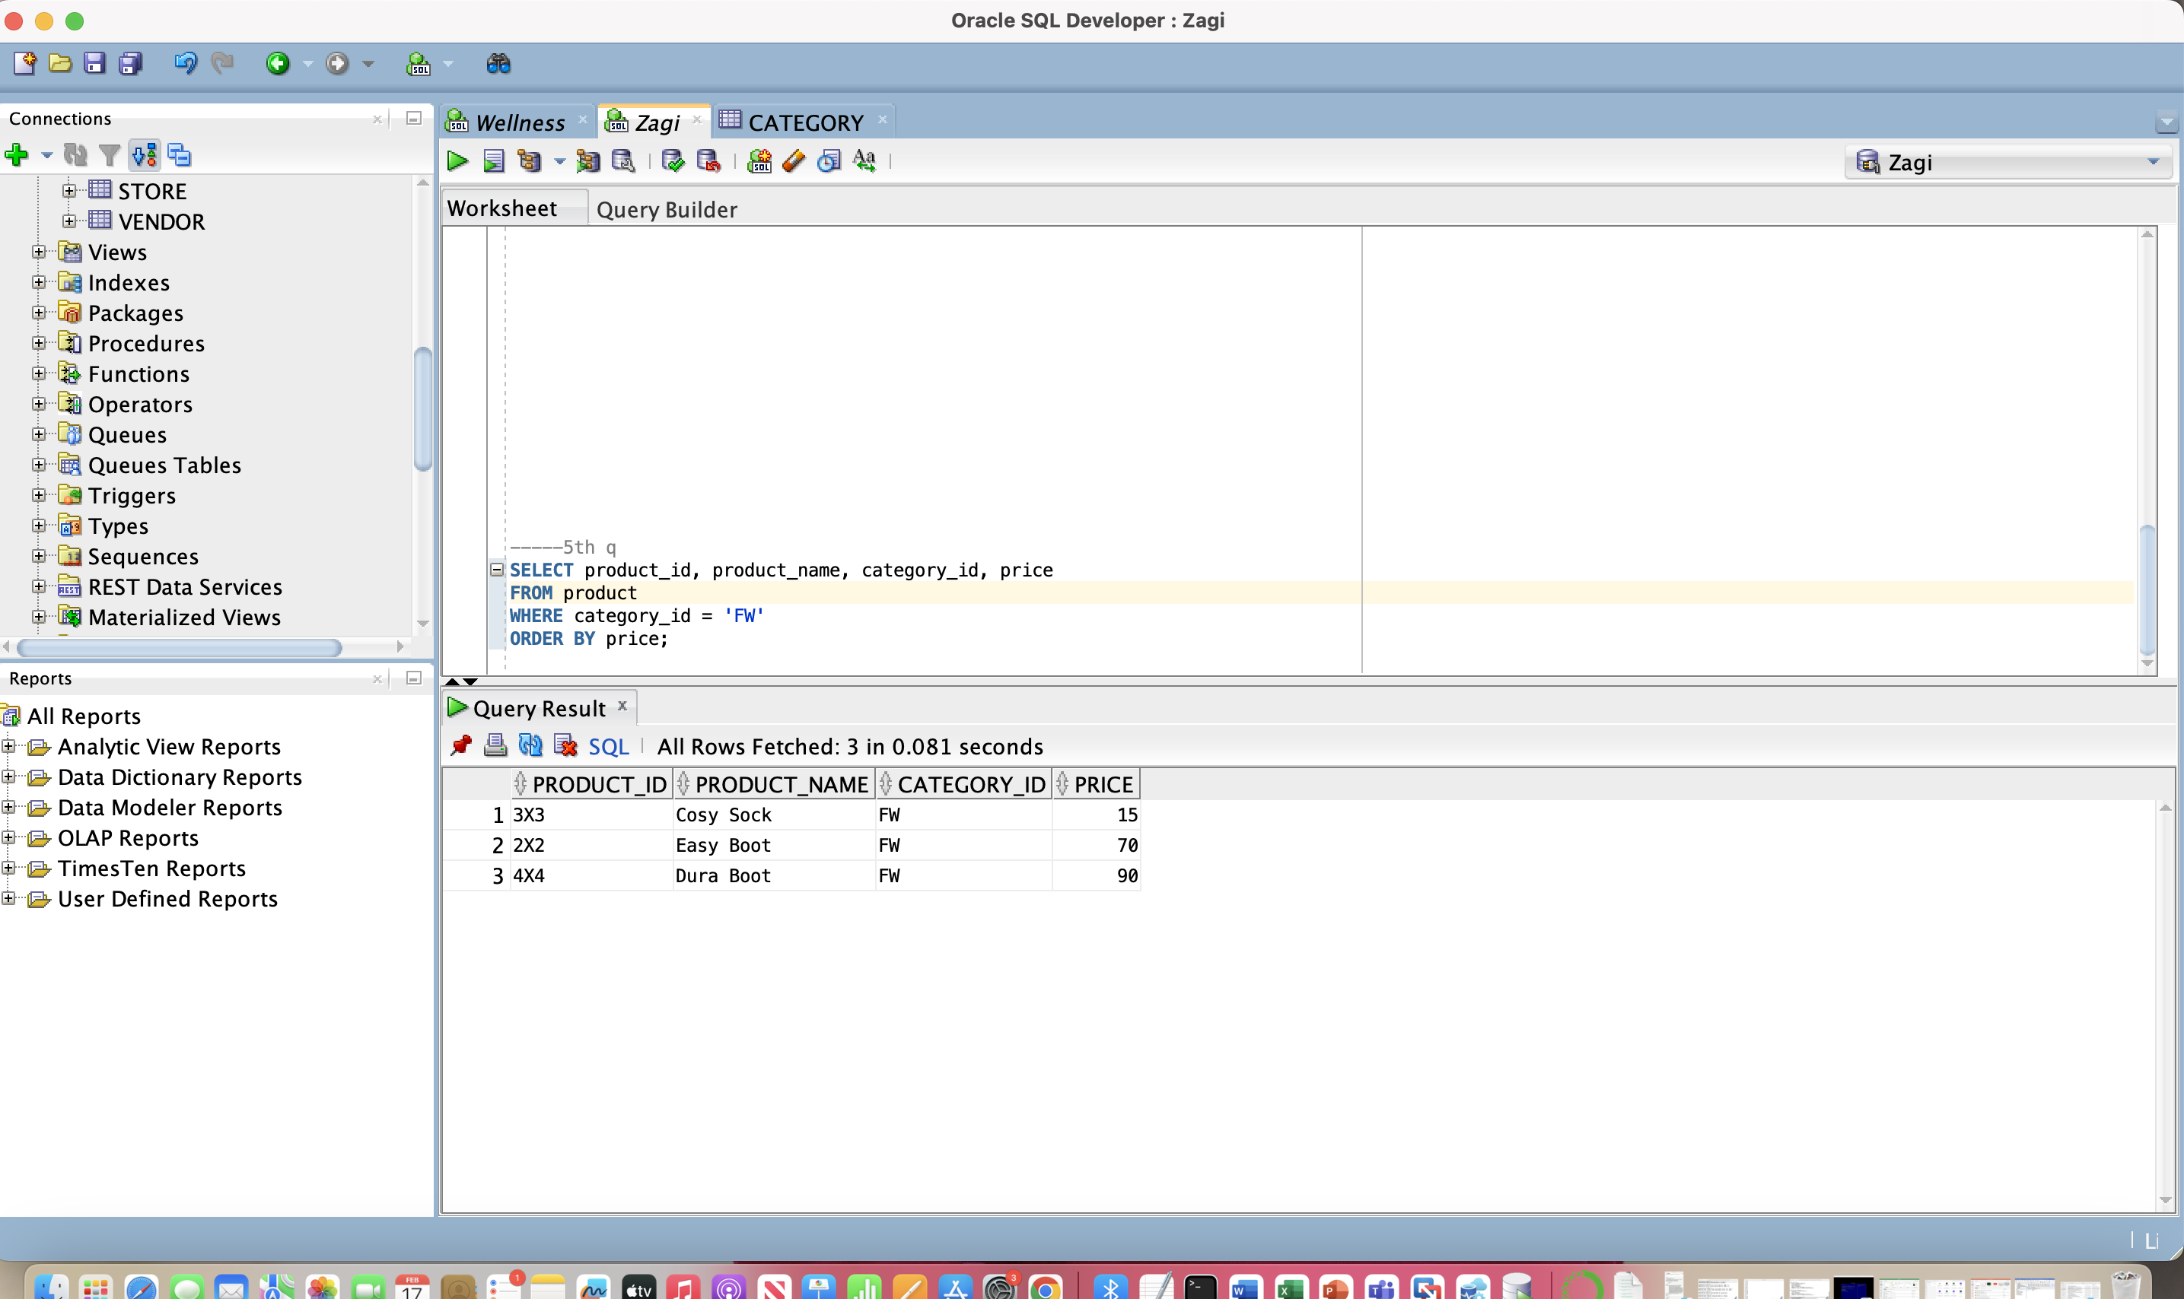

***(6)*** *Retrieve the product ID, product name, category ID, and   
 product price for each product in the FW product category,   
 sorted by product price in descending order*

***SELECT product_id, product_name, category_id, price***

***FROM product***

***WHERE category_id = 'FW'***

***ORDER BY price DESC;***

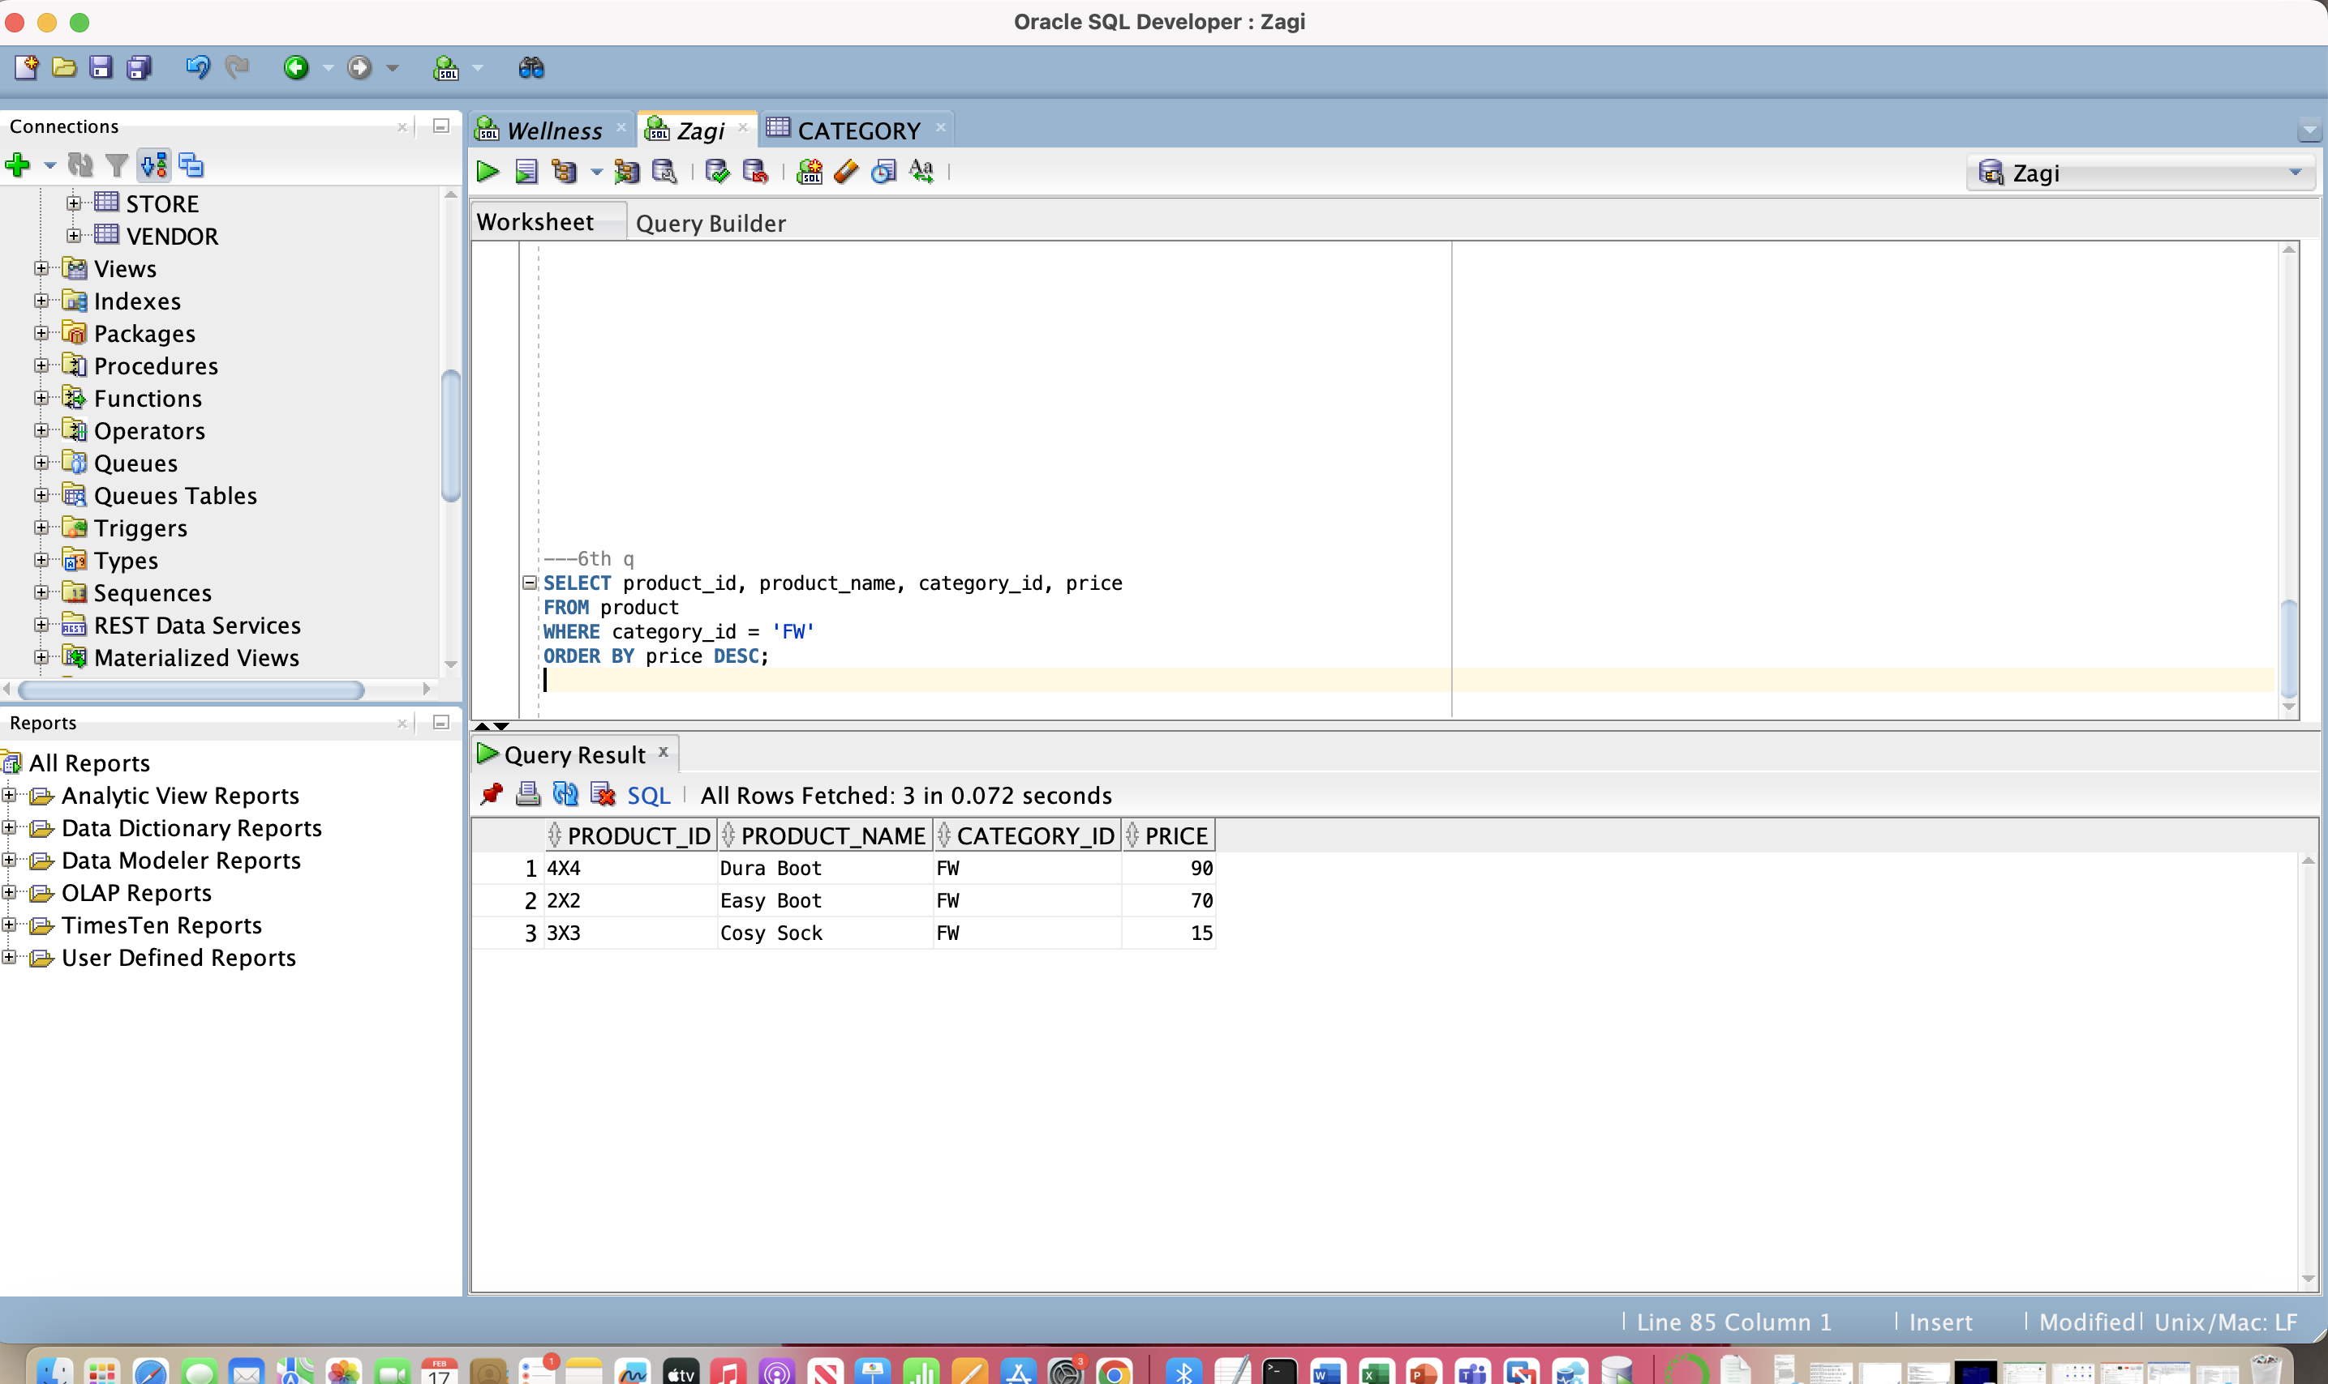

***(7)*** *Retrieve the product ID, product name, category ID, and   
 product price for each product, sorted by category ID and,   
 within the same category ID, by product price*

SELECT product_id, product_name, category_id, price

FROM product

ORDER BY category_id, price;

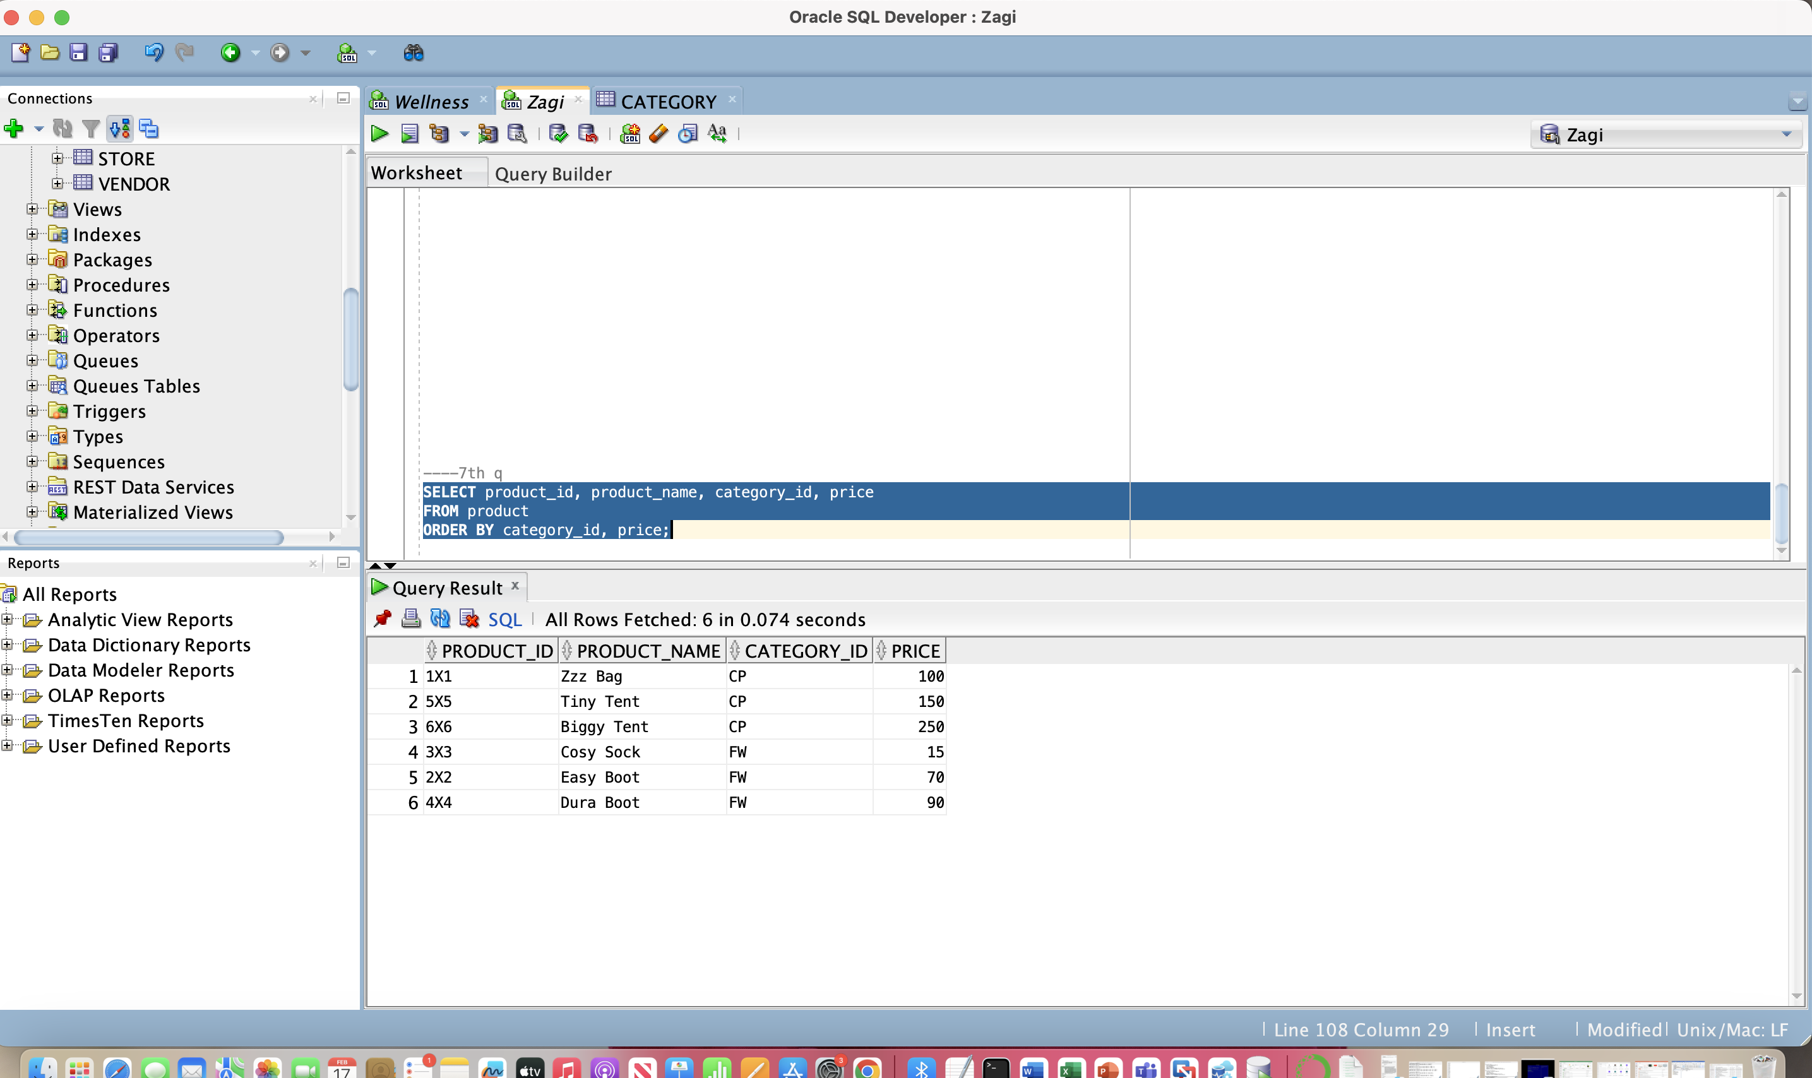

***(8)*** *Retrieve the record for each product whose product name   
 contains the phrase ’Boot’*

SELECT product_id, product_name, category_id, price

FROM product

WHERE product_name LIKE '%Boot%';

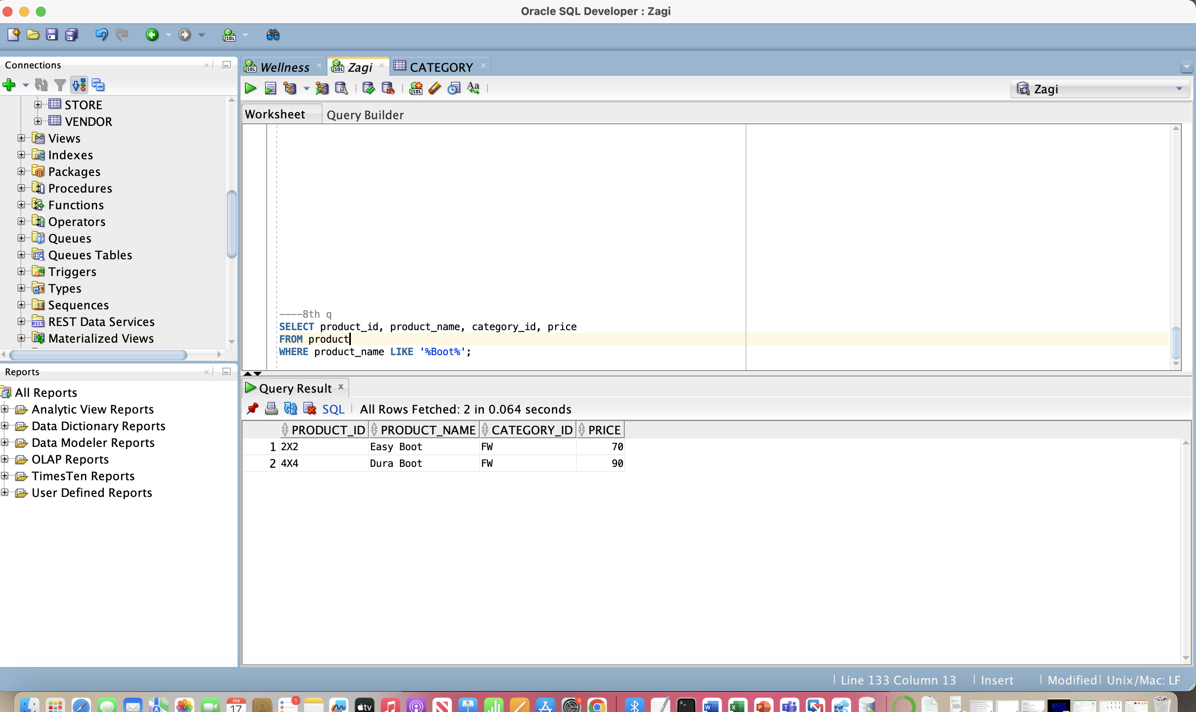

***(9)*** *Retrieve the average price of all products*

SELECT AVG(price) AS avg_price

FROM product;

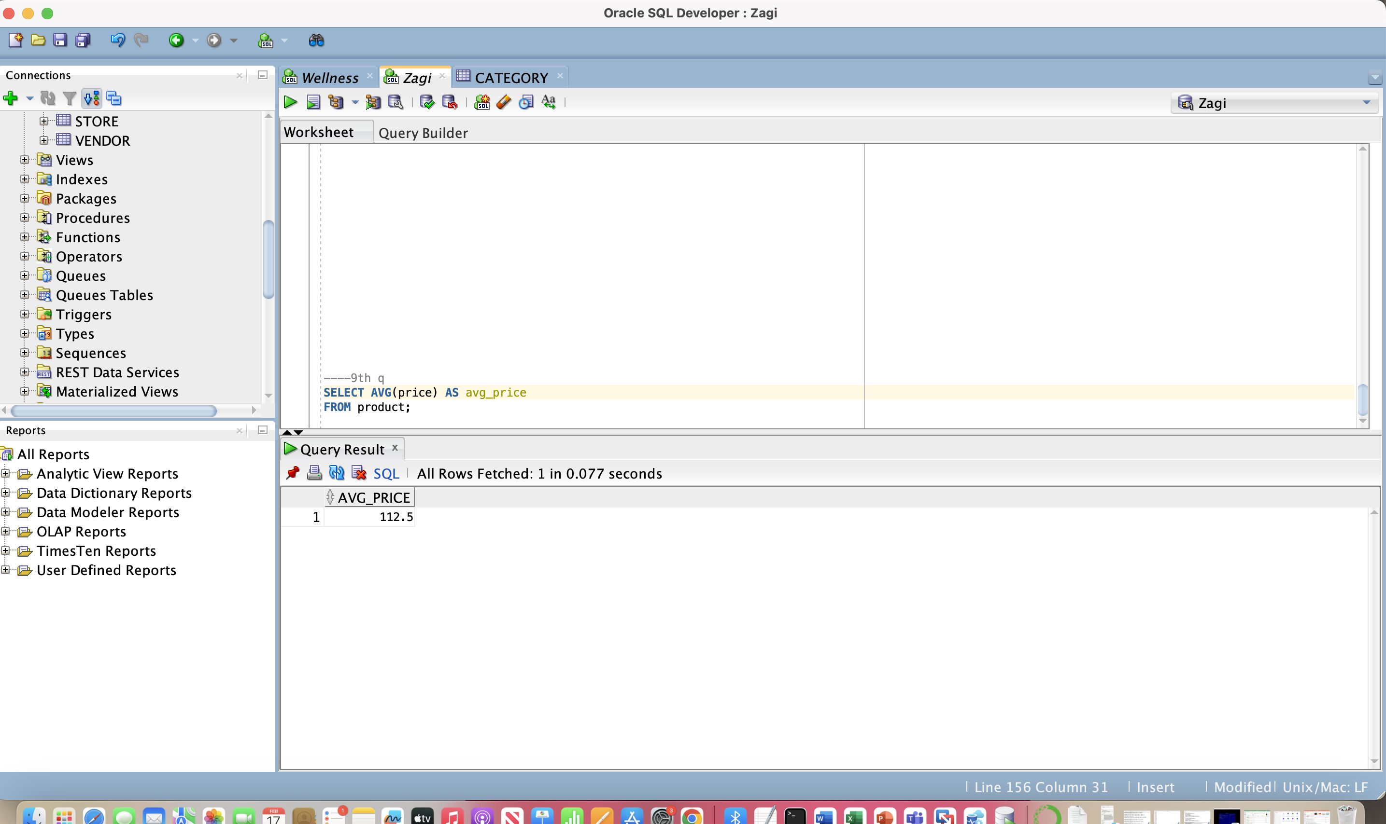

***(10)*** *Show how many products we offer for sale*

SELECT COUNT(*) AS tot_pro

FROM product;

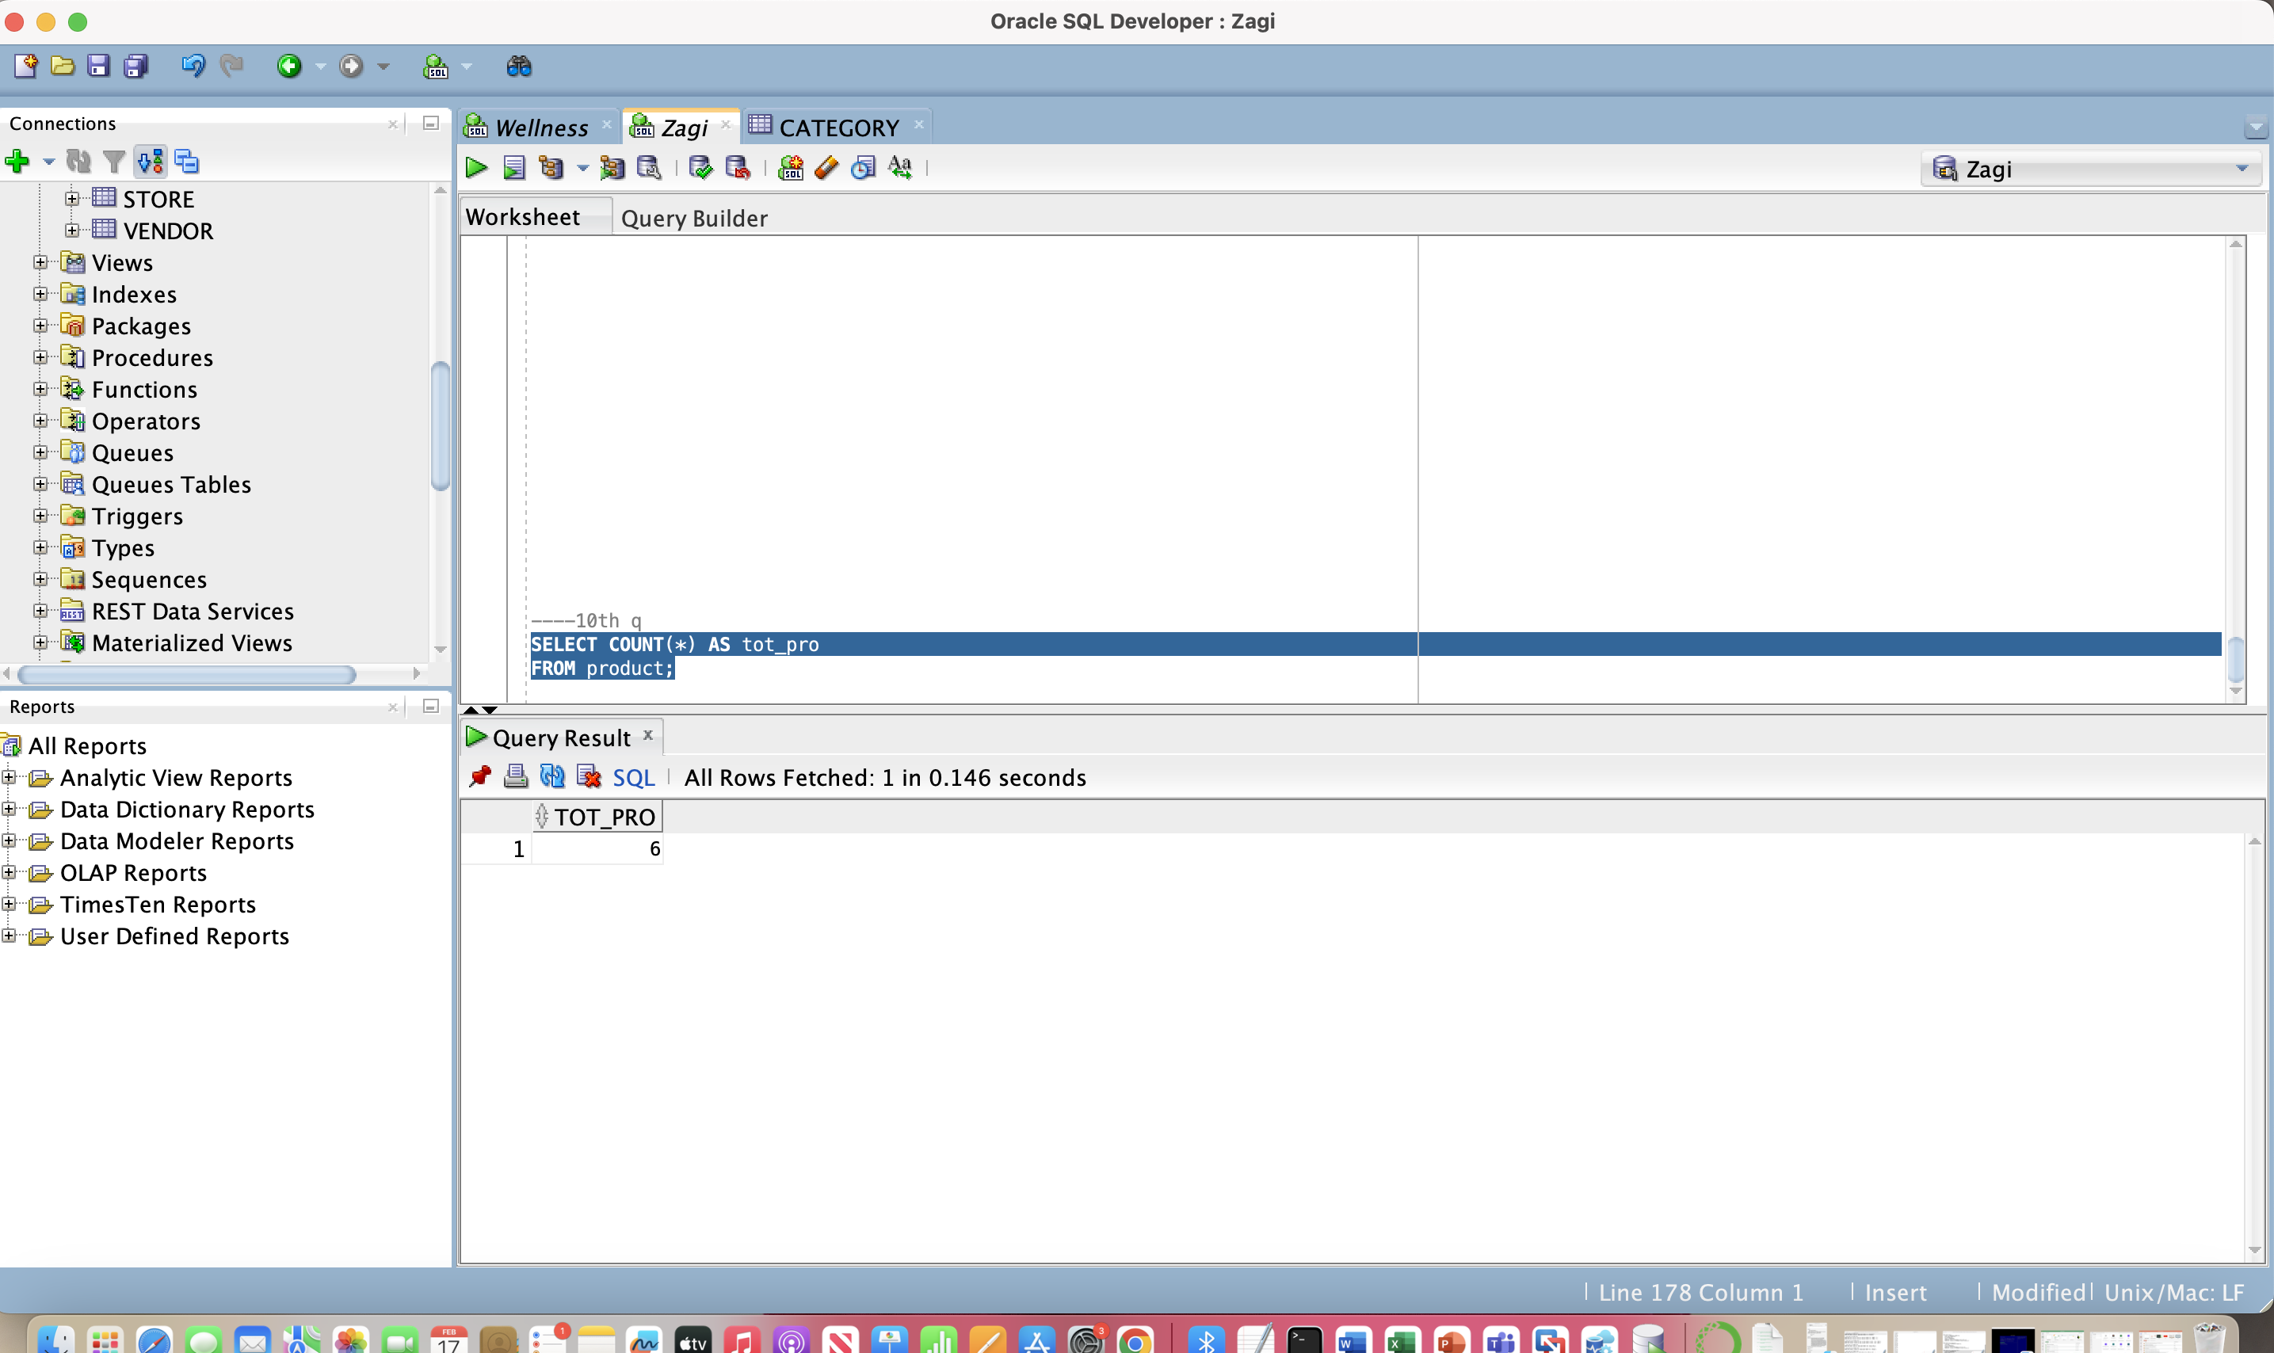

***(11)*** *Retrieve the number of vendors that supply our products*

SELECT COUNT(DISTINCT vendor_id) AS tot_vend

FROM product;

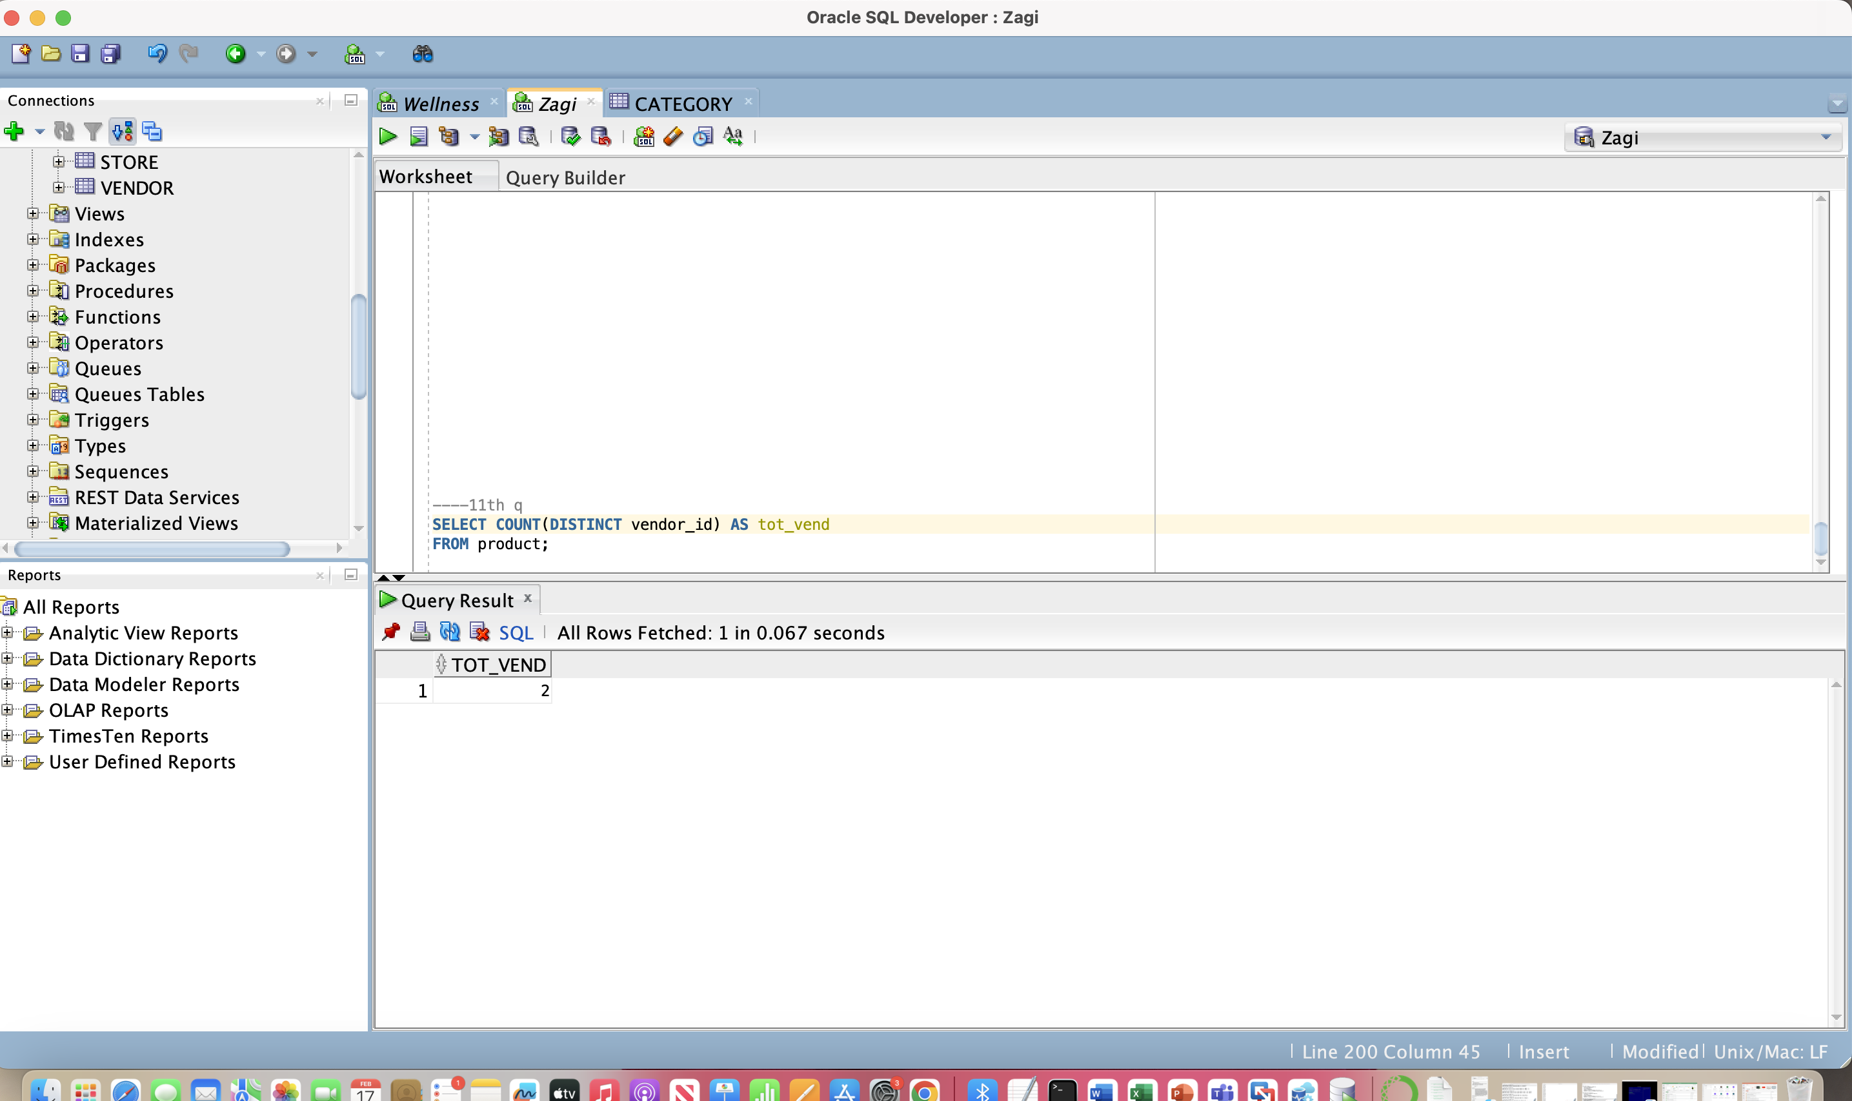

***(12)*** *Retrieve the number of products, average product price, lowest   
 product price, and highest product price in the CP product   
 category*

SELECT

COUNT(*) AS total_products,

AVG(price) AS avg_price,

MIN(price) AS low_price,

MAX(price) AS high_price

FROM product

WHERE category_id = 'CP';

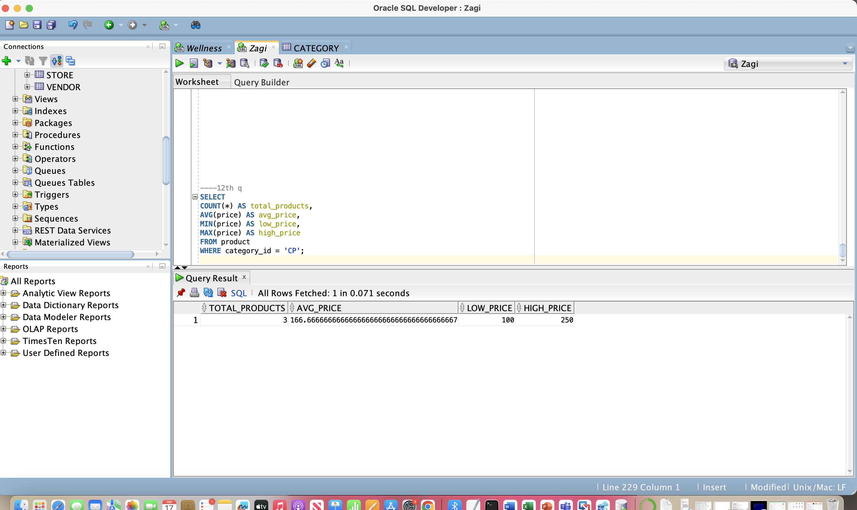

***(13)*** *For each vendor, retrieve the vendor ID, number of products   
 supplied by the vendor, and average price of the products   
 supplied by the vendor*

*SELECT vendor_id,COUNT(*) AS tot_products,AVG(price) AS avg_price*

*FROM product*

*GROUP BY vendor_id;*

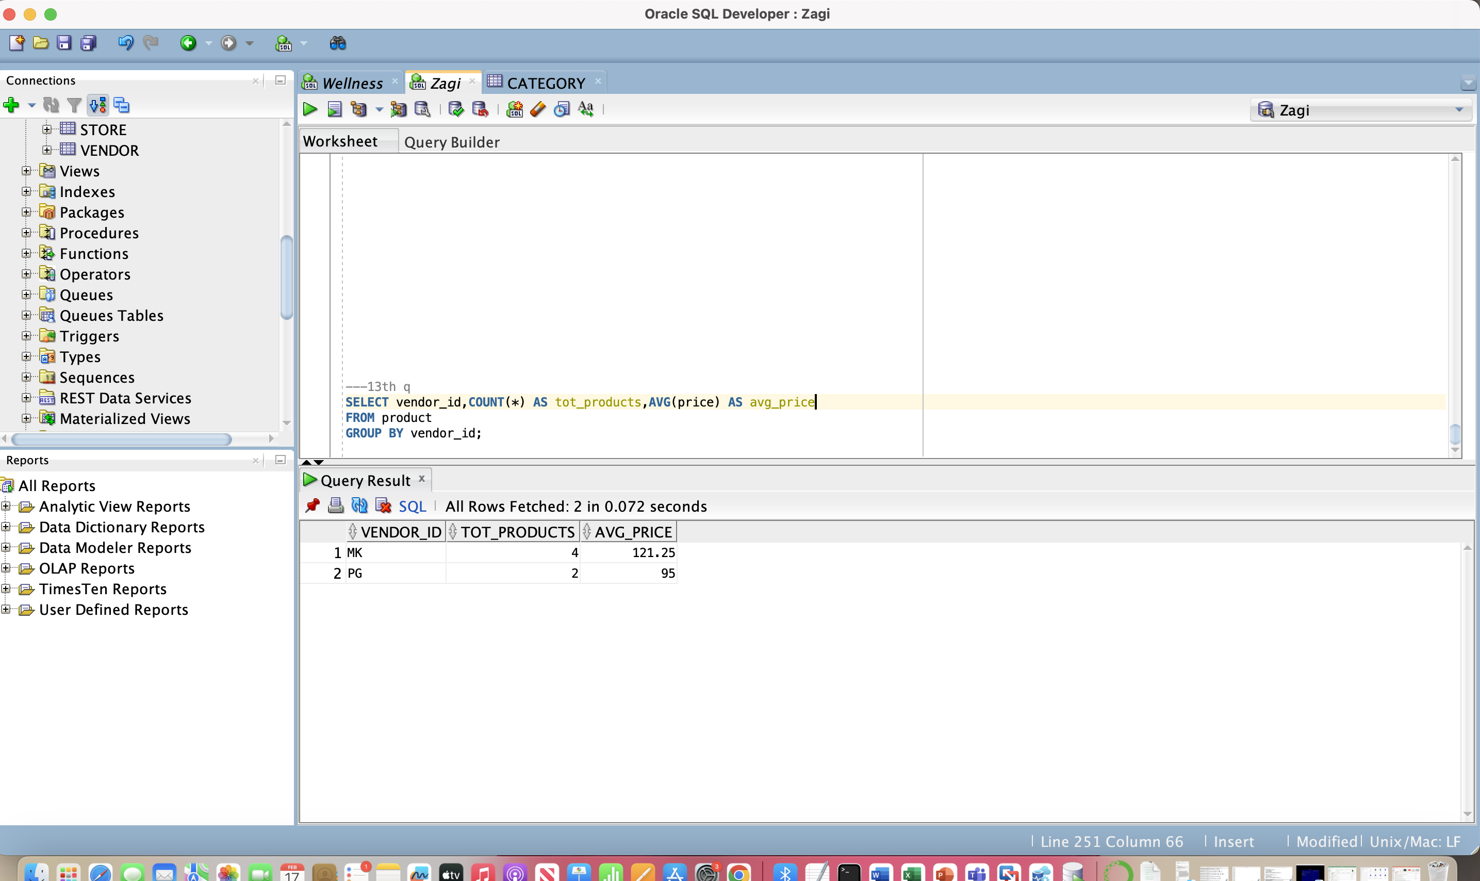

***(14)*** *For each vendor, retrieve the number of products supplied by the vendor and the average price of the products supplied by the vendor*

SELECT vendor_id,COUNT(*) AS tot_pro,AVG(Price) AS average_price

FROM product

GROUP BY vendor_id;

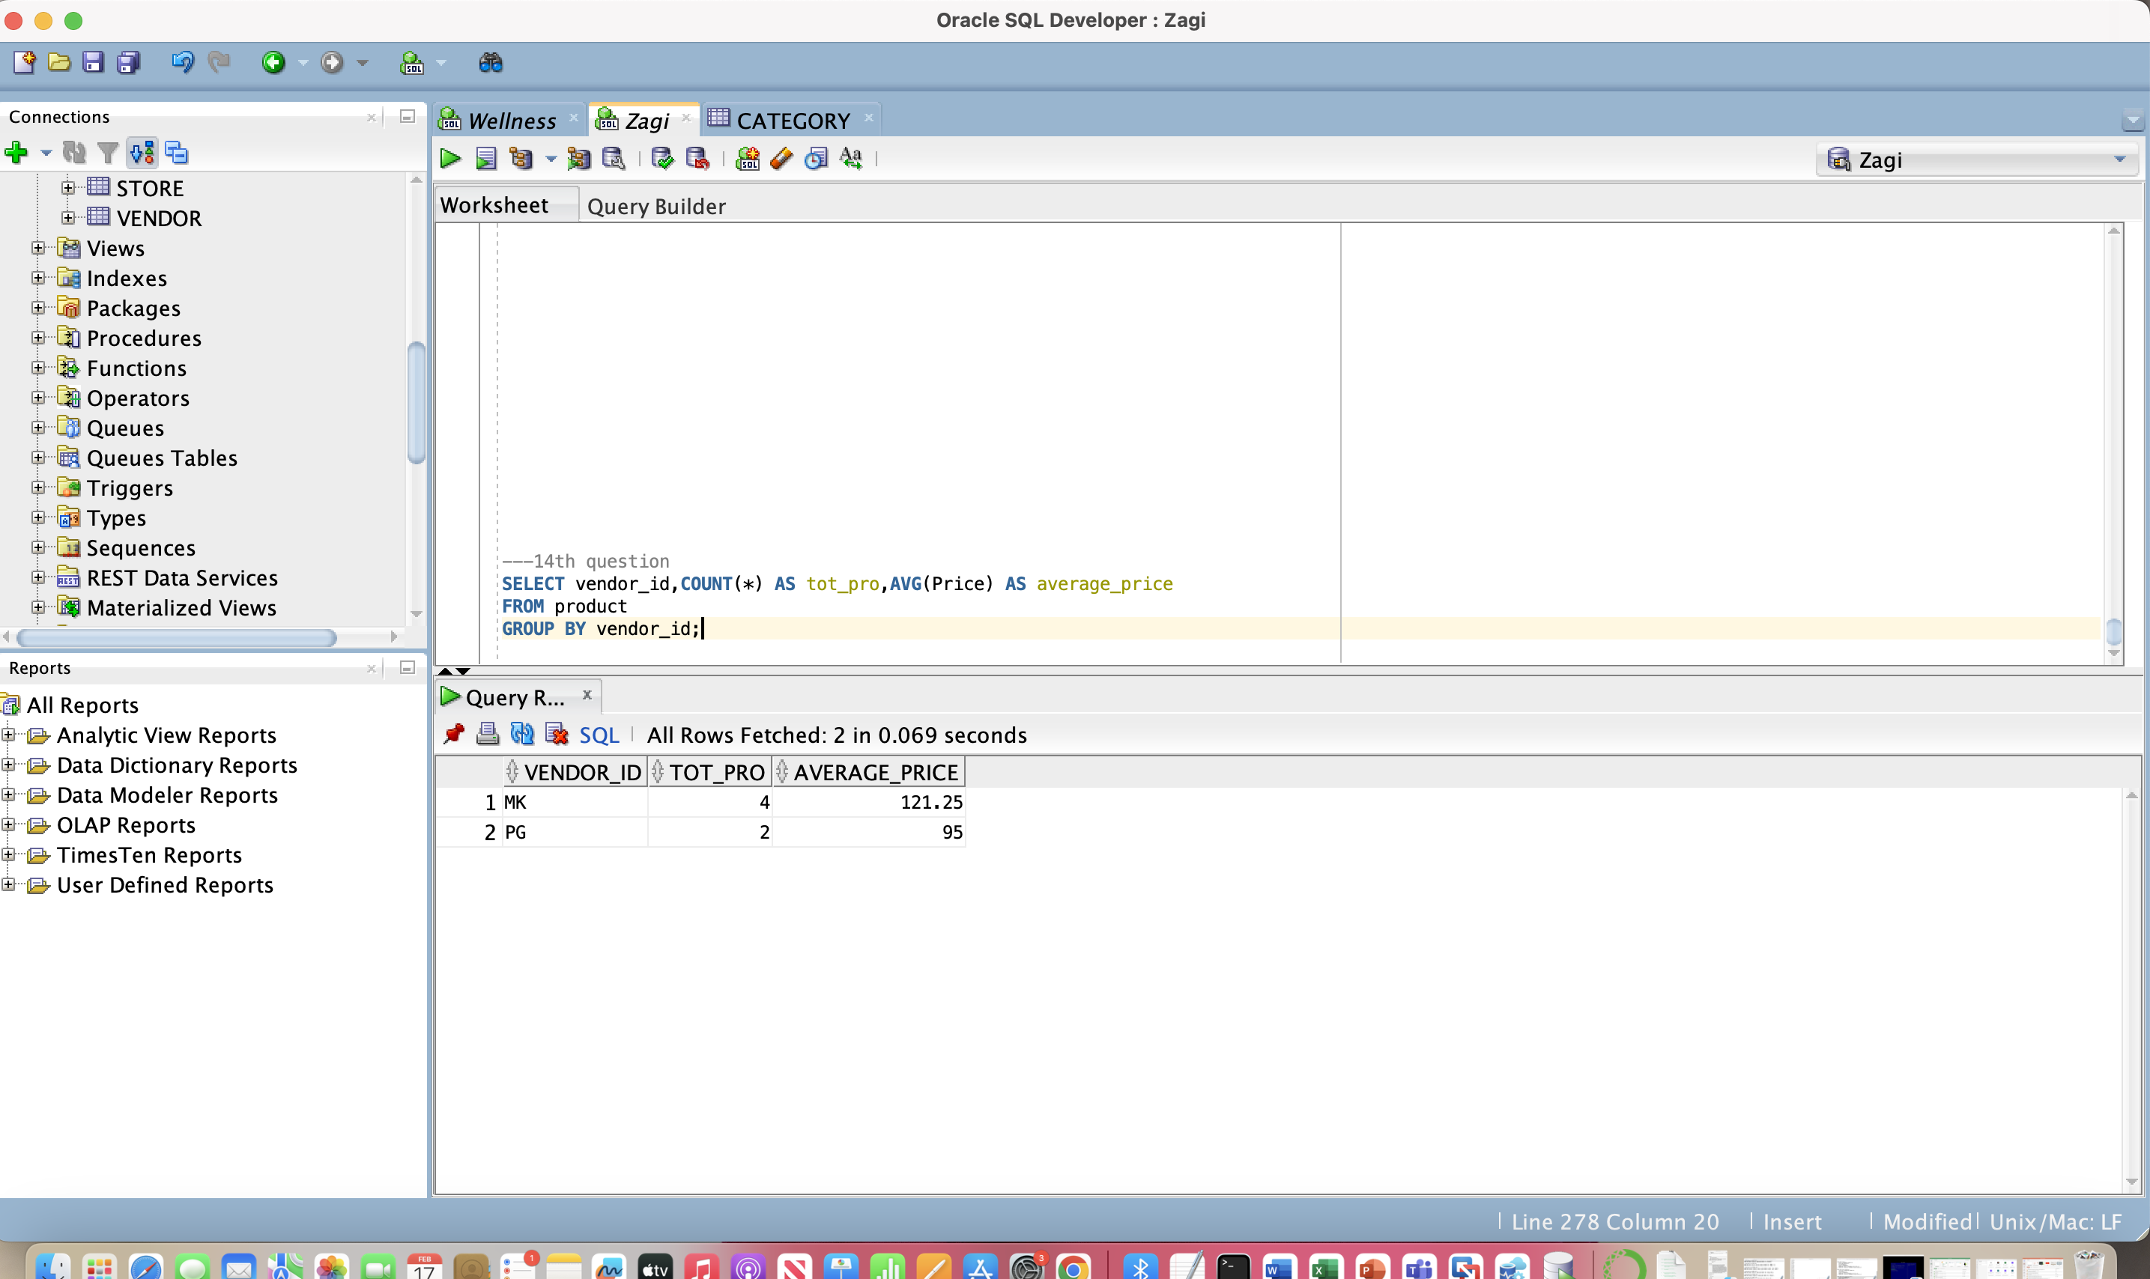

***(15)*** *For each vendor, retrieve the vendor ID and the number of   
 products with a product price of $100 or higher supplied by the   
 vendor*

SELECT vendor_id,COUNT(*) AS prdouct_price_g100

FROM product

WHERE price >= 100

GROUP BY vendor_id;

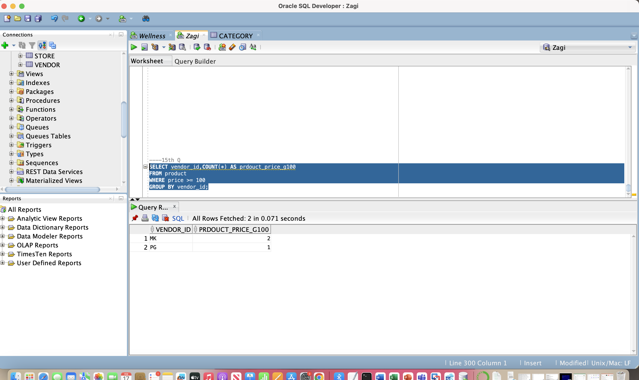

***(16)*** *Consider the groups of products where each group contains the products that are from the same category supplied by the same vendor. For each such group, retrieve the vendor ID, product category ID, number of products in the group, and average price of the products in the group.*

**SELECT vendor_id,category_id,COUNT(*) AS sum_product,**

**AVG(price) AS average_price**

**FROM product**

**GROUP BY vendor_id, category_id;**



***(17)*** *For each product, retrieve the ProductID value and the total   
 number of product items sold within all sales transactions.*

SELECT p.product_id,SUM(s.quantity) AS items_sold_sum

FROM product p

JOIN sales_transaction_product s ON p.product_id = s.product_id

GROUP BY p.product_id;

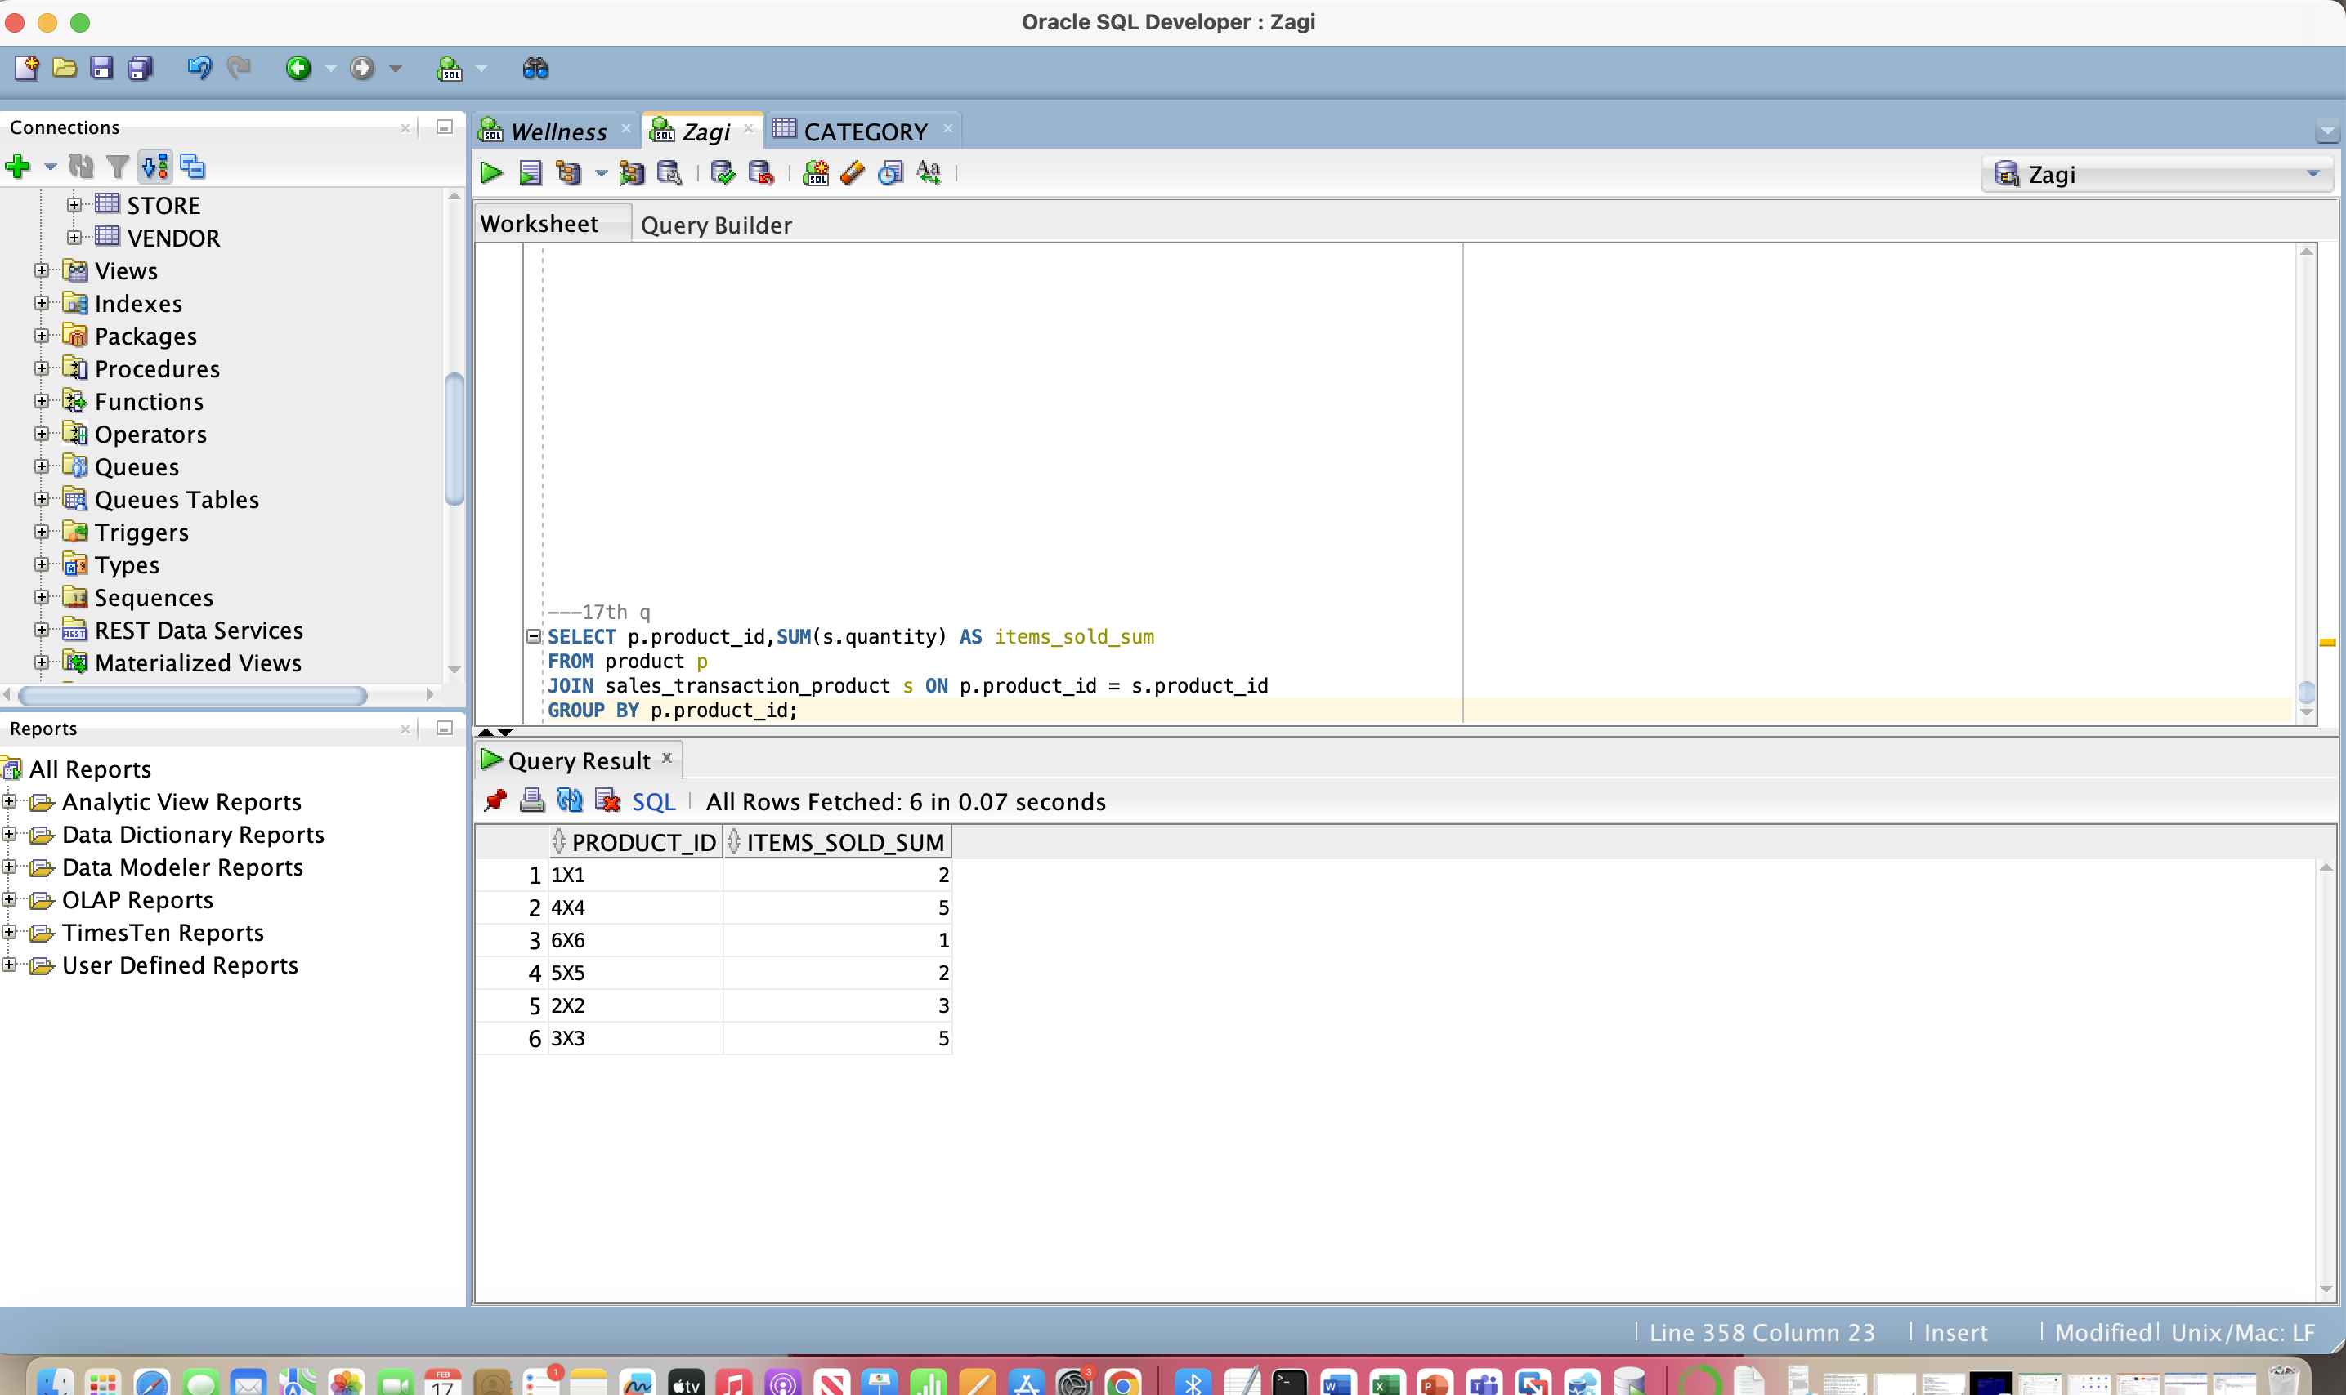

***(18)*** *Consider the groups of products where each group contains the products that are from the same category and supplied by the same vendor. For each such group that has more than one product, retrieve the vendor ID, product category ID, number of products in the group, and average price of the products in the group.*

SELECT vendor_id,category_id,COUNT(*) AS sum_products,

AVG(price) AS avg_price

FROM product

GROUP BY category_id,vendor_id;

HAVING sum_products > 1;

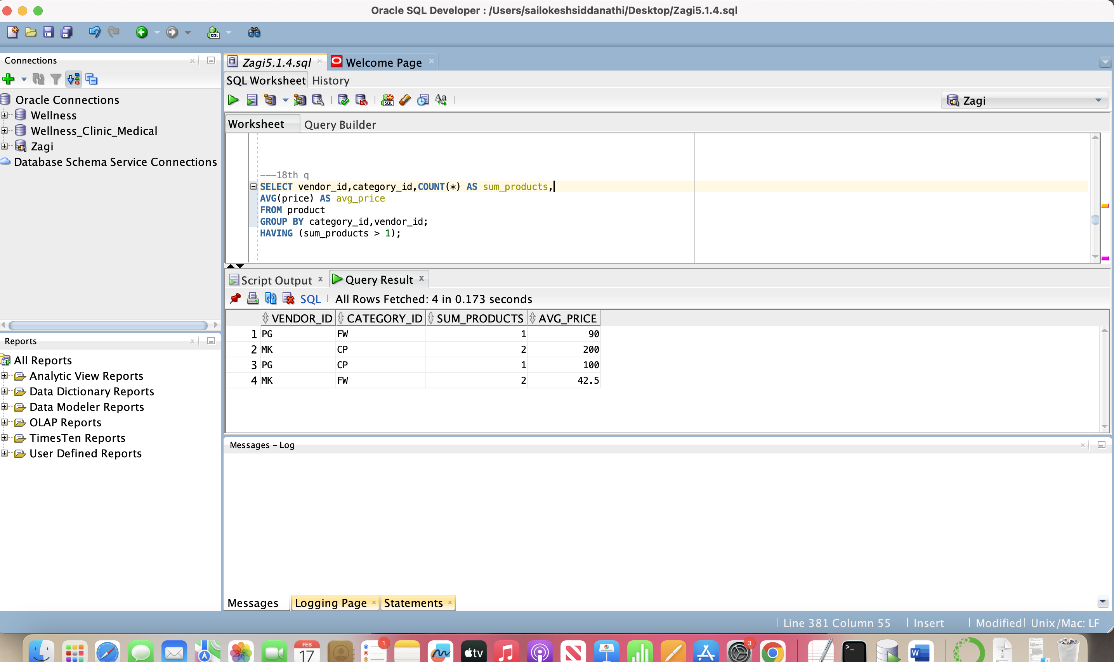

***(19)*** *For each product that has more than three items sold within all  
 sales transactions, retrieve the ProductID value and the total  
 number of product items sold within all sales transactions*

SELECT Product_id,SUM(Quantity) AS tot_items

FROM sales_transaction_product

GROUP BY Product_id

HAVING SUM(Quantity) > 3;

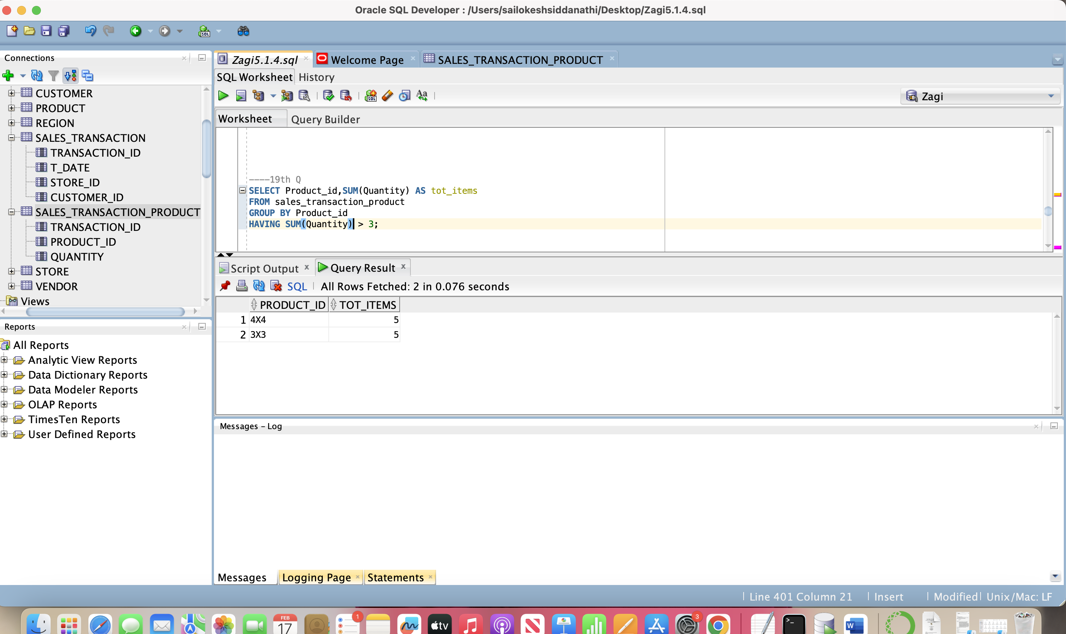

***(20)*** *For each product whose product price is below the average price of all products, retrieve the product ID, product name, and product price*

SELECT product_id,product_name,price

FROM product

WHERE price < (SELECT AVG(price) FROM product);

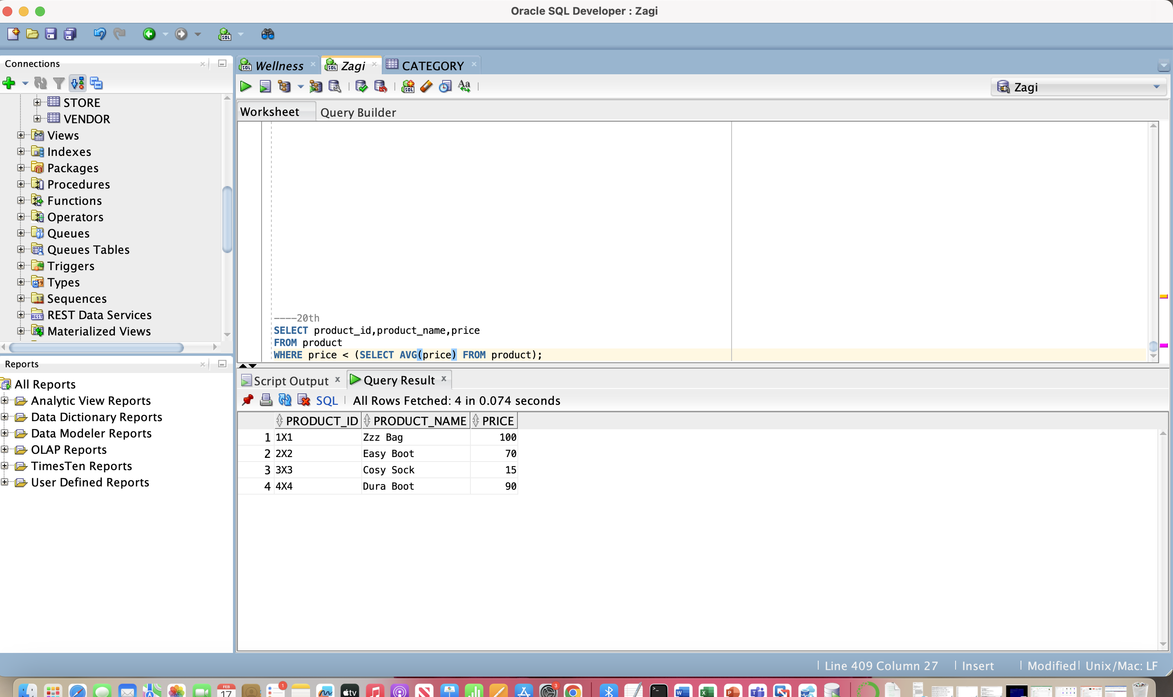

(21) Retrieve the product id, product name, and product price for products whose product id is either 1X1 or 2X2 or 3X3

SELECT product_id,product_name,price

FROM product

WHERE product_id IN ('1X1', '2X2', '3X3');

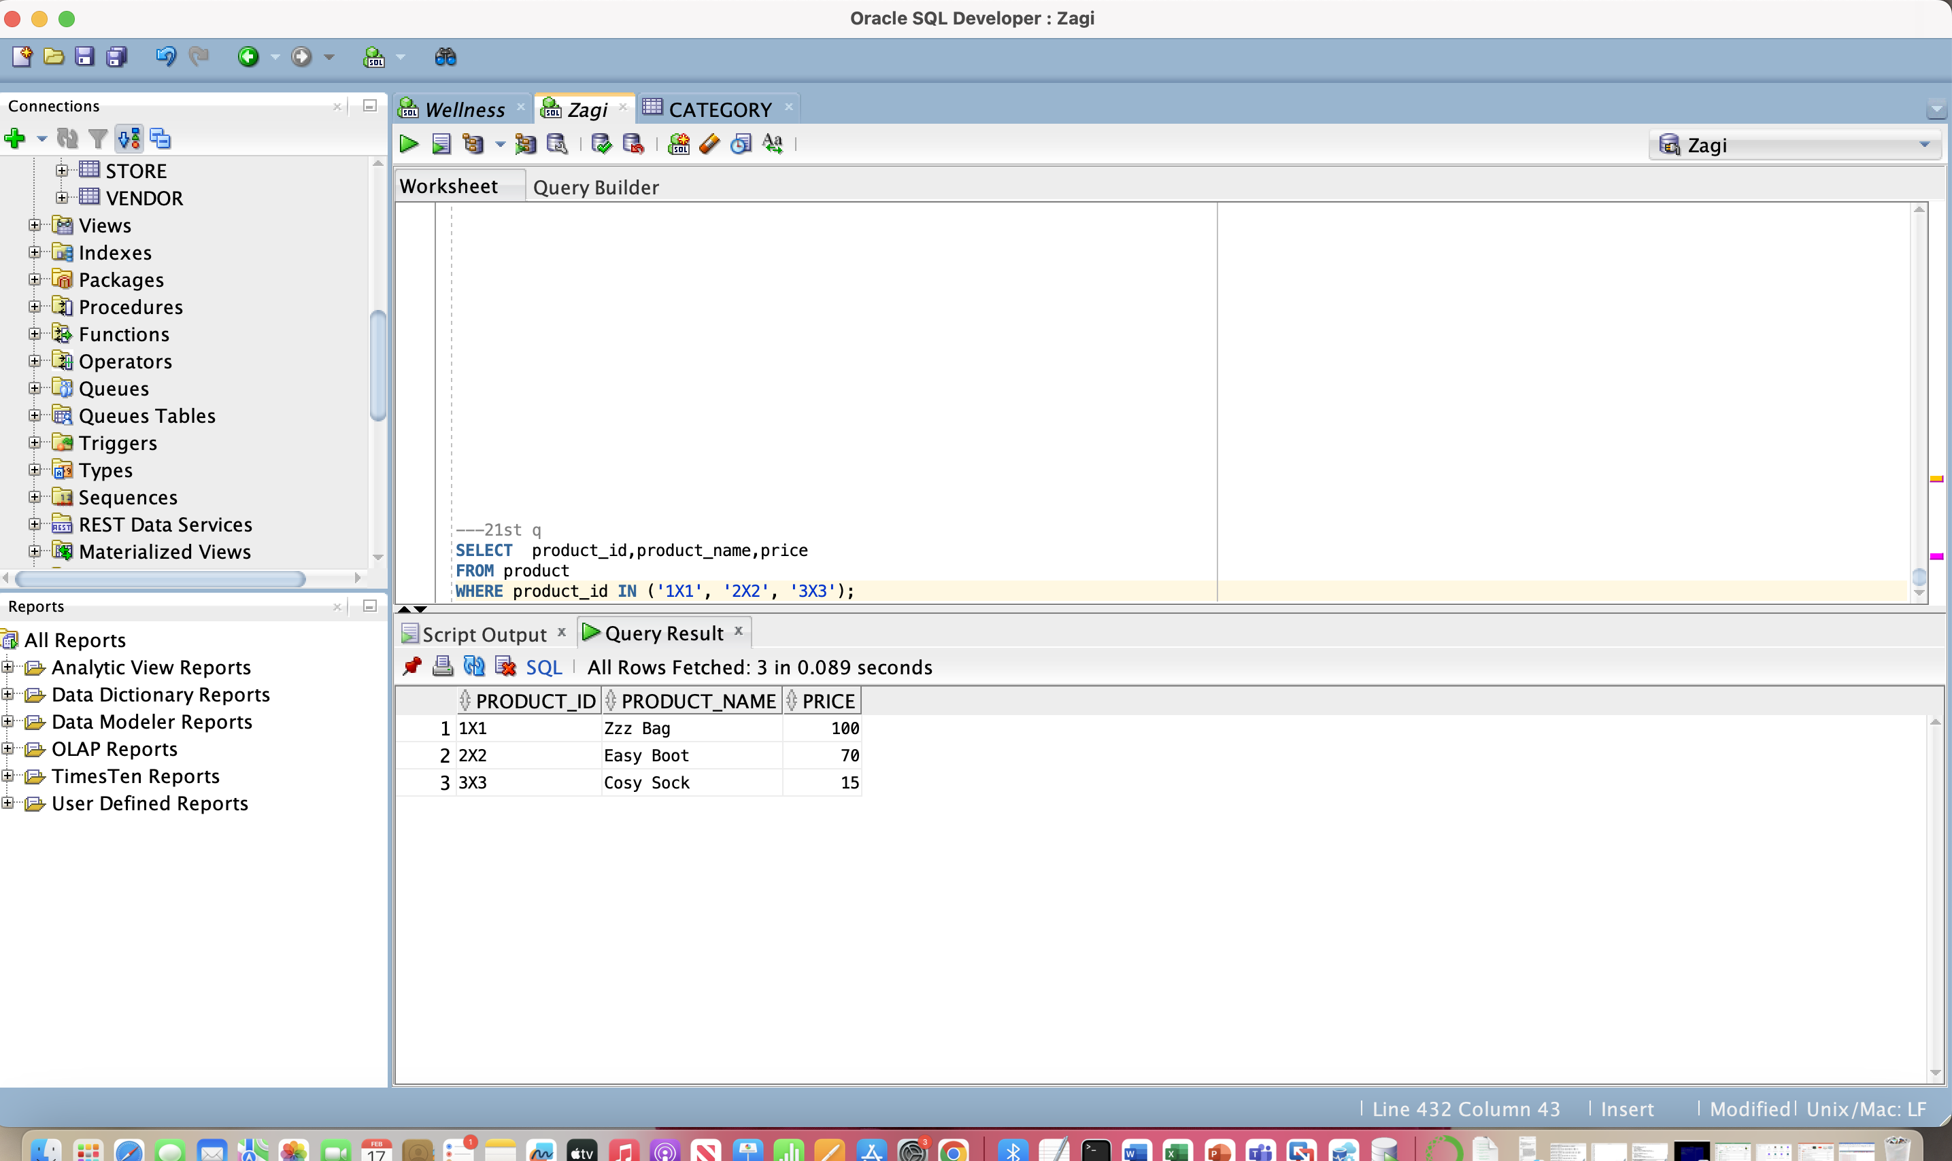

(22) for Each product that has more than more than three items sold within all sales transactions, retrieve the product ID, product name, and product price.

SELECT p.product_id,p.product_name,p.price

FROM product p

JOIN (

SELECT product_id, SUM(quantity) AS total_sold

FROM sales_transaction_product

GROUP BY product_id

HAVING SUM(quantity) > 3

) s ON p.product_id = s.product_id;

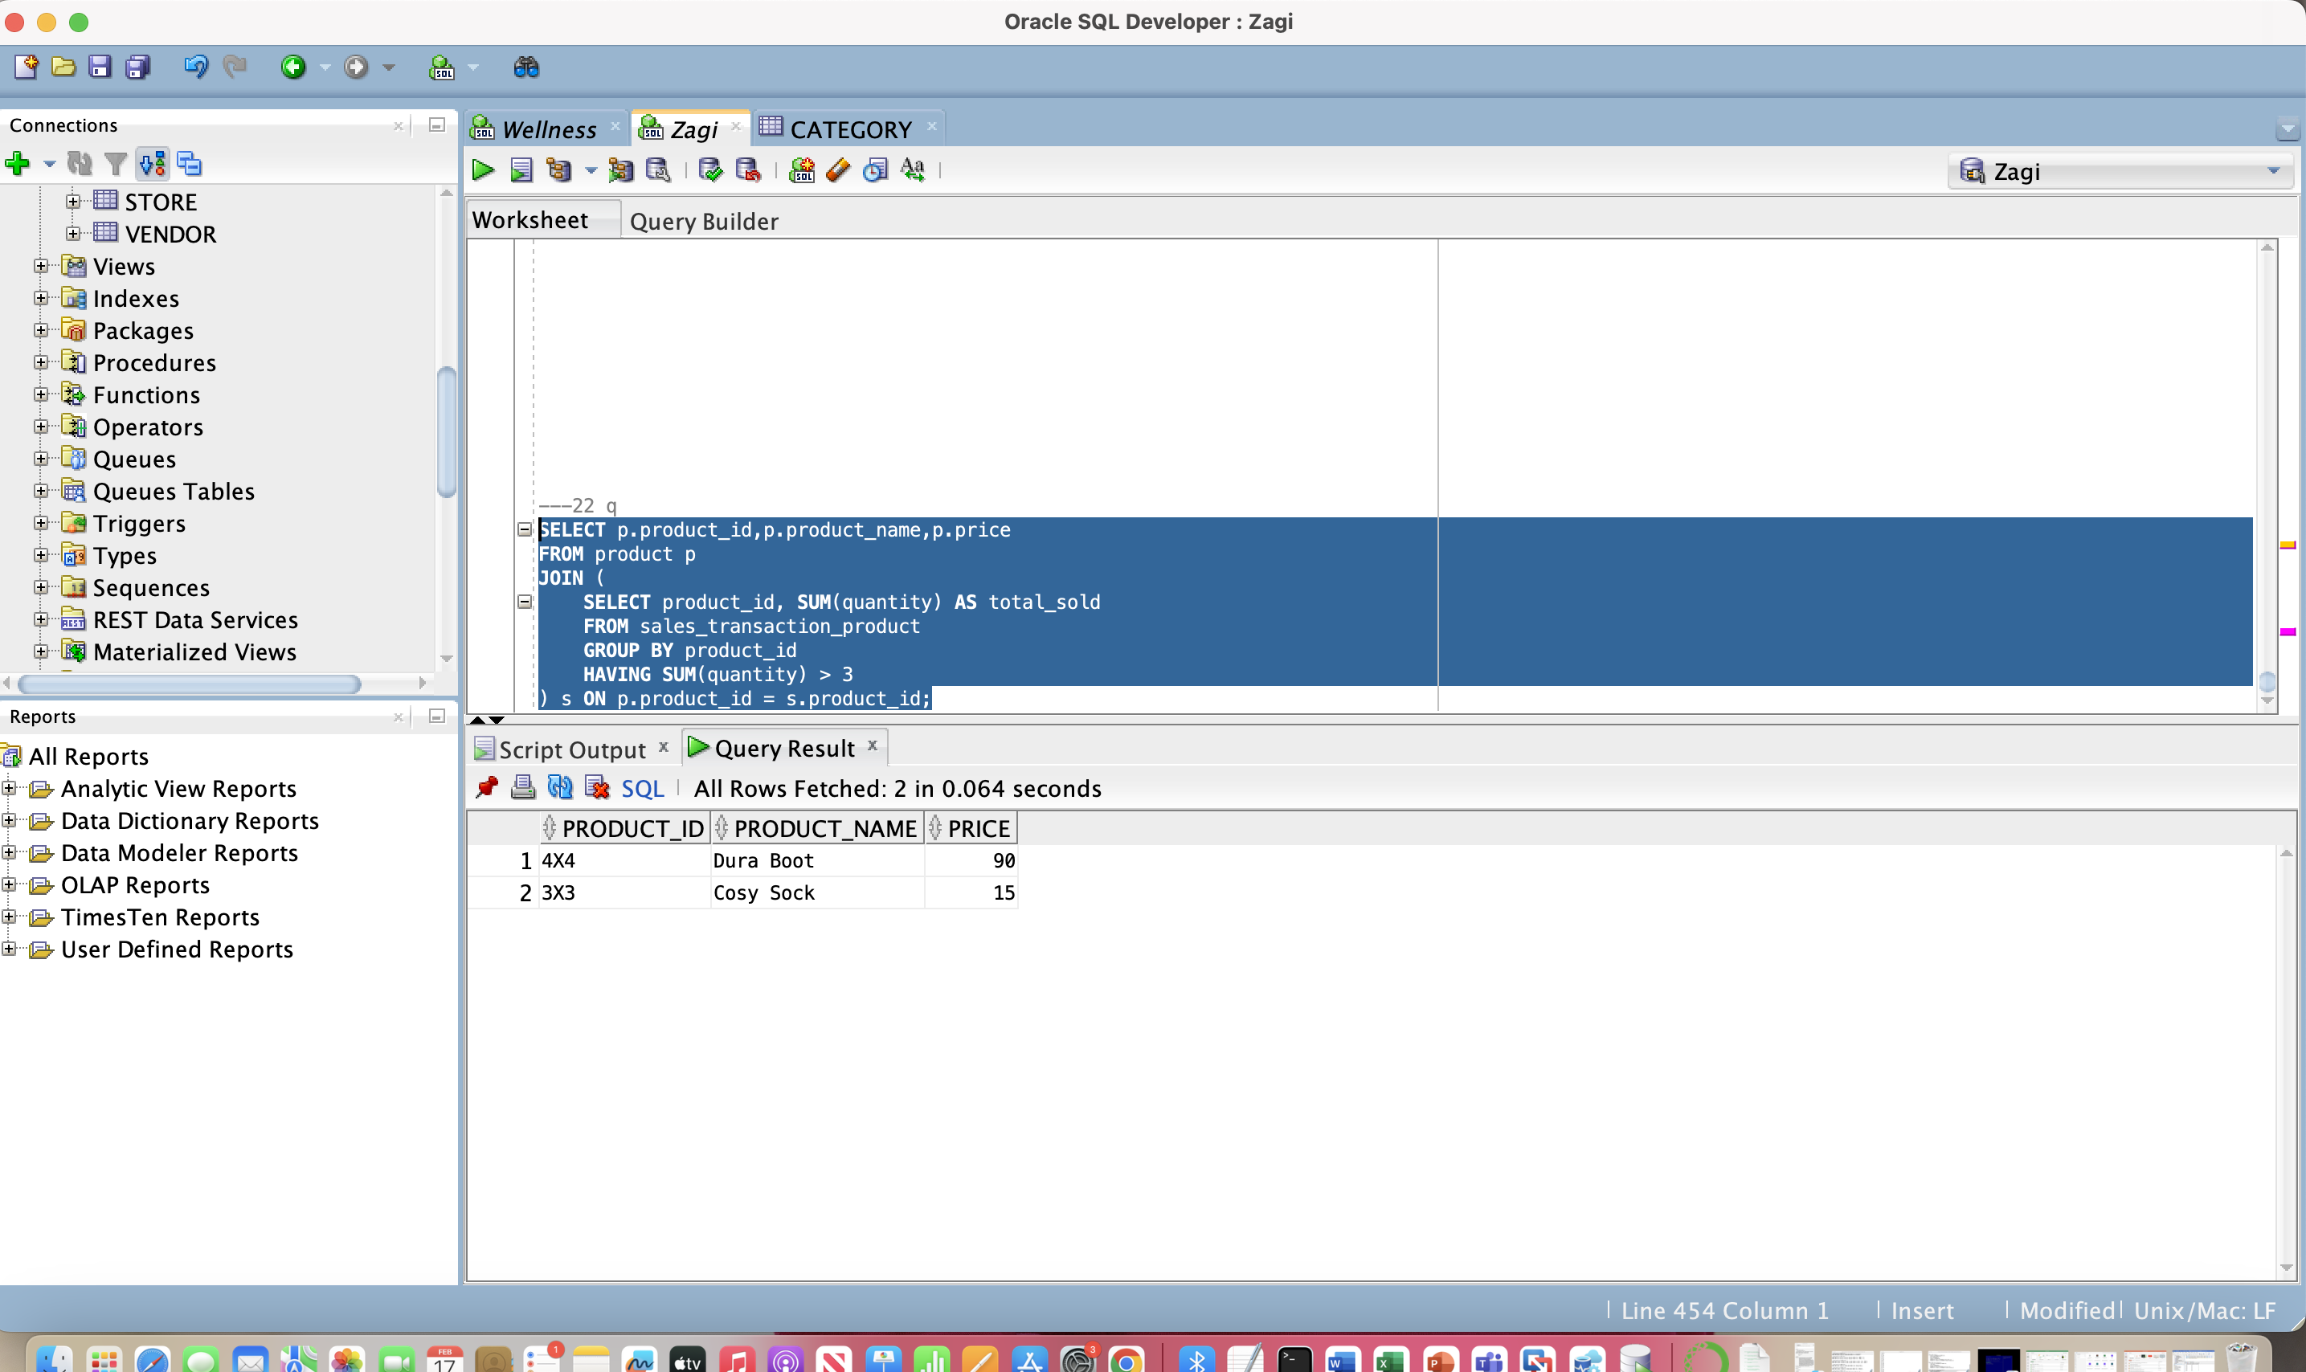

(23) for each product, retrieve the product ID, name of the product, name of the vendor of the product, and price of the product.

SELECT p.product_id,p.product_name,v.vendor_name, p.price

FROM product p

JOIN vendor v ON p.vendor_id = v.vendor_id;

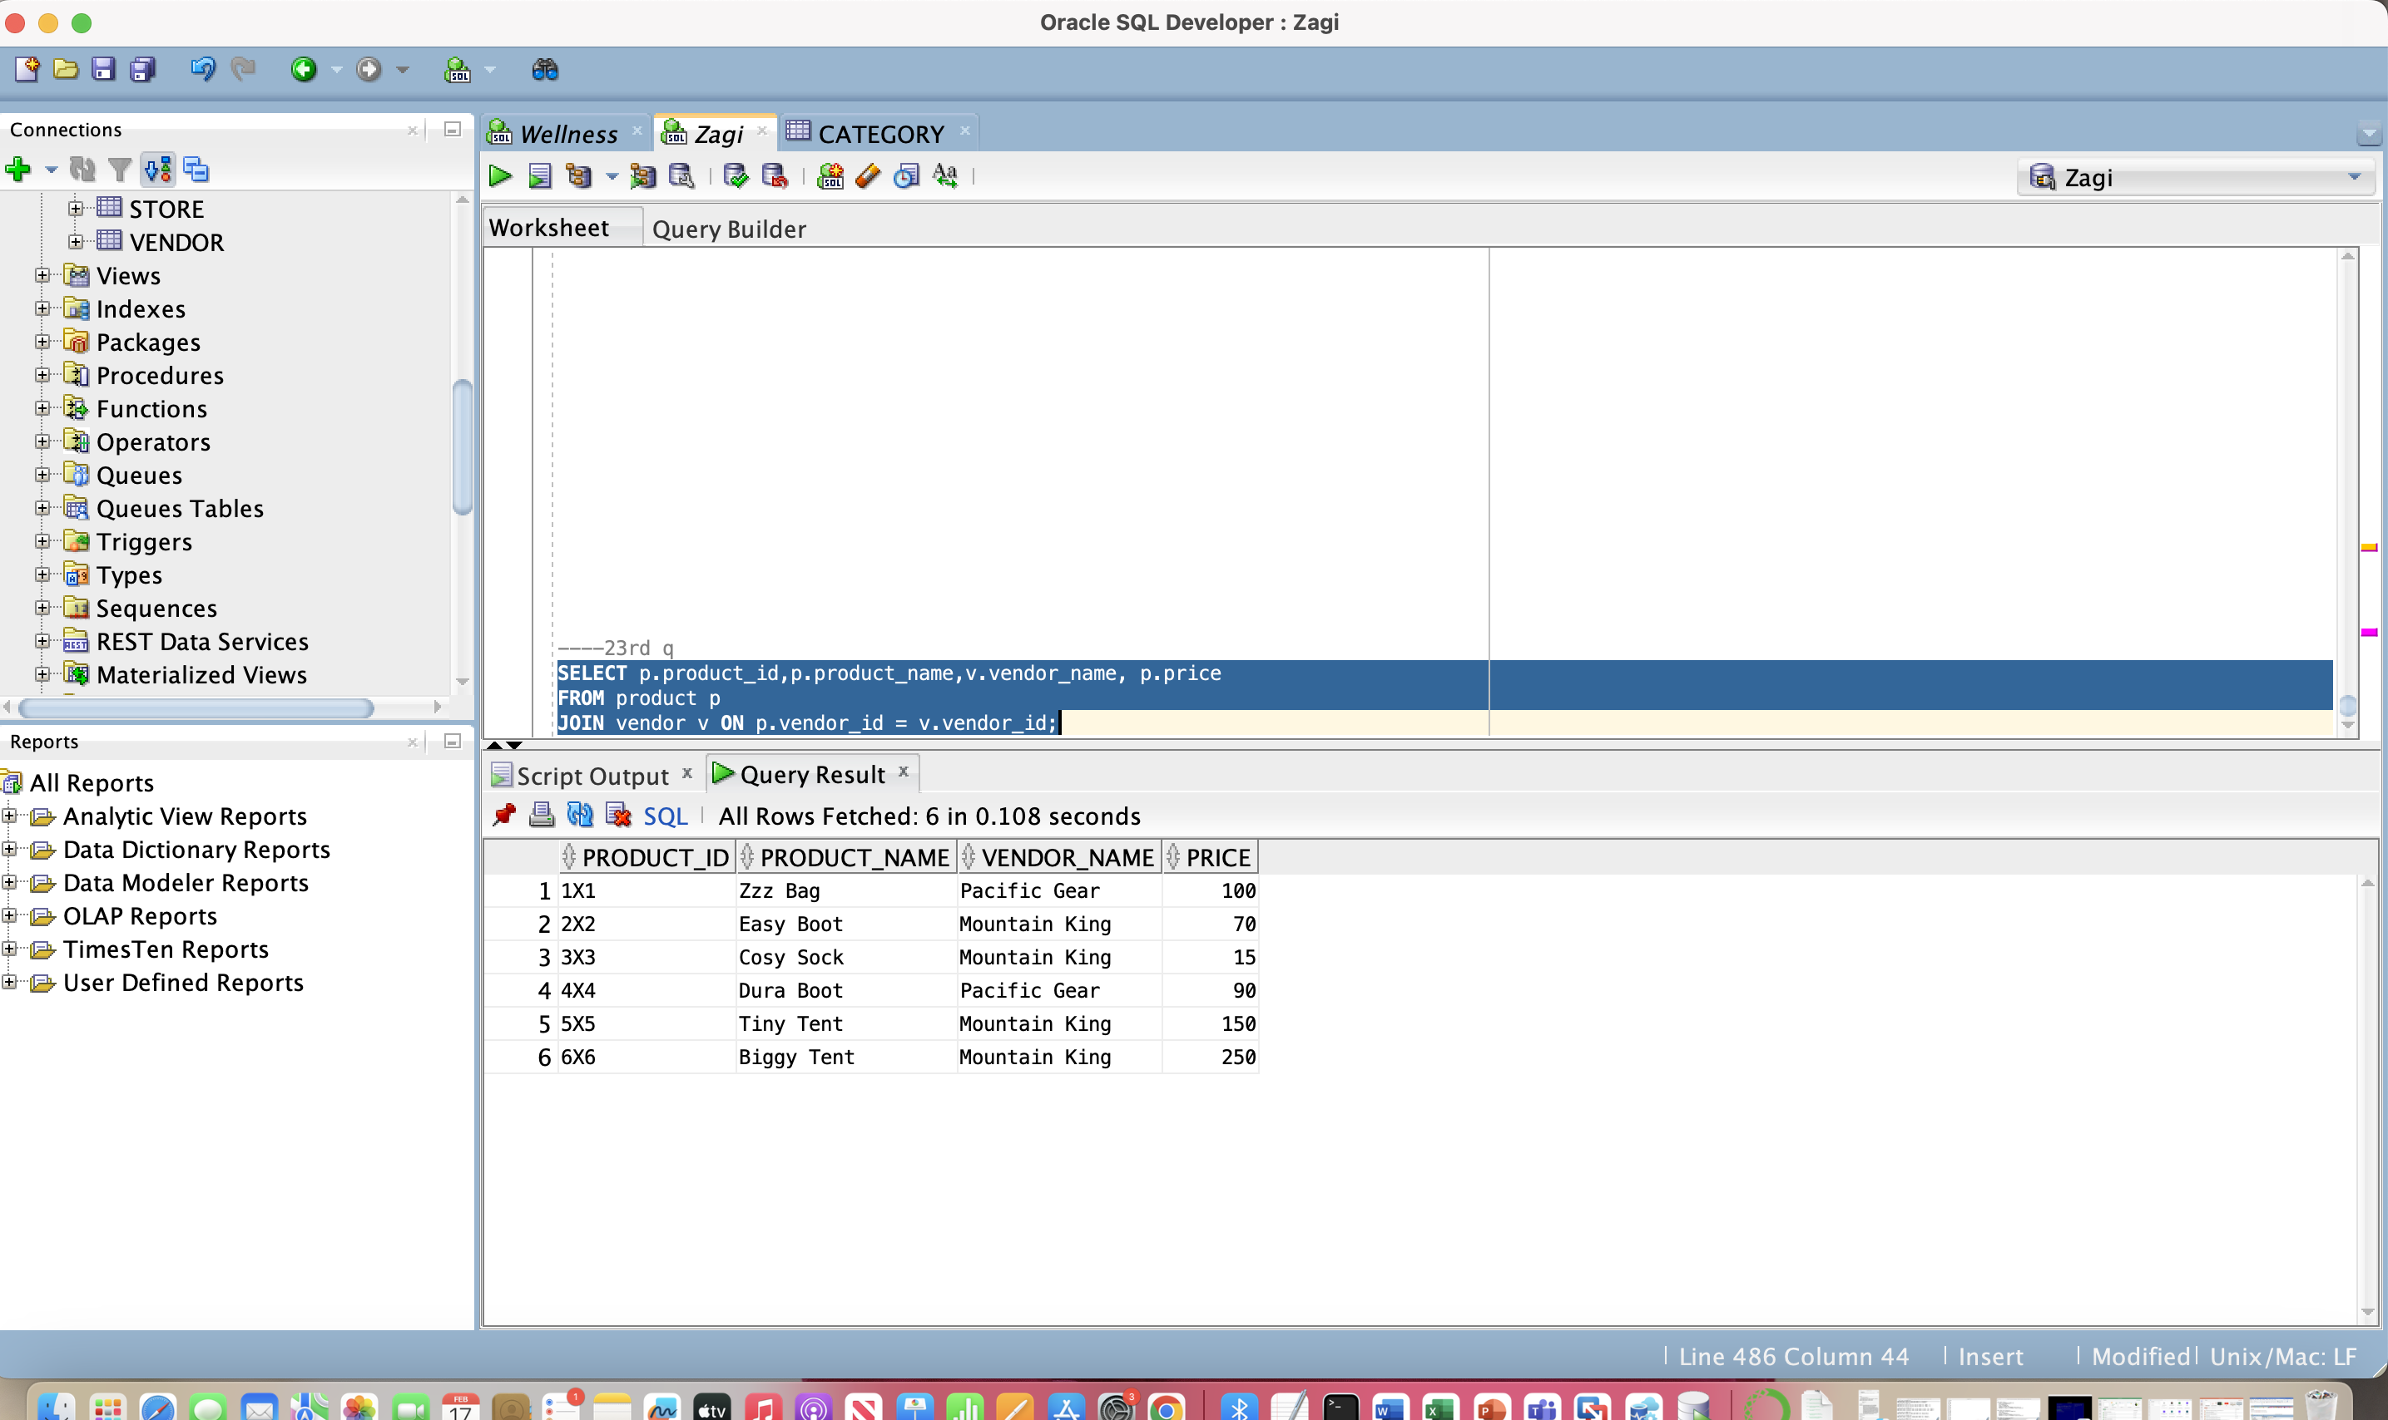

(24) for each line item of a sales transaction, retrieve the transaction identifier, date of the transaction, name of the product that was sold, quantity sold, and amount charged, sorted by transaction identifier.

SELECT Sales_Transaction.Transaction_ID, Sales_Transaction.T_Date, Product.Product_Name,SALES_TRANSACTION_PRODUCT.Quantity AS QuantitySold,

CAST(Product.Price AS DECIMAL(10, 2)) * SALES_TRANSACTION_PRODUCT.Quantity AS AmountCharged

FROM Sales_Transaction

JOIN SALES_TRANSACTION_PRODUCT ON Sales_Transaction.Transaction_ID = SALES_TRANSACTION_PRODUCT.Transaction_ID

JOIN SALES_TRANSACTION_PRODUCT ON SALES_TRANSACTION_PRODUCT.Product_ID = SALES_TRANSACTION_PRODUCT.Product_ID

JOIN Product ON SALES_TRANSACTION_PRODUCT.Product_ID = Product.Product_ID

ORDER BY Sales_Transaction.Transaction_ID;

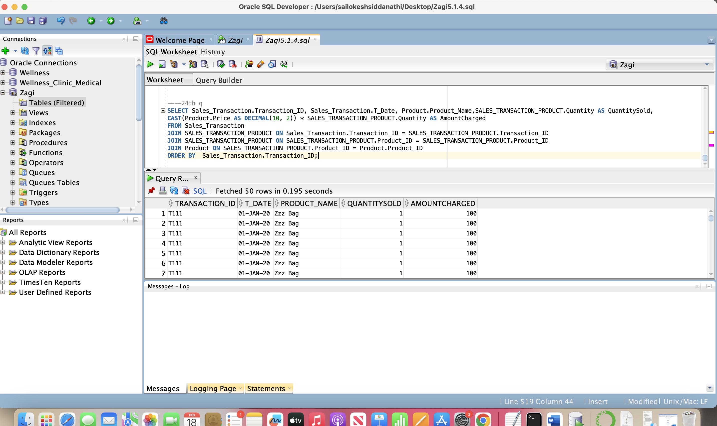

Stored Procedures:

(25) Write a procedure that will insert a record to the product table

CREATE OR REPLACE PROCEDURE SUM_PRODUCT(

p_Product_ID PRODUCT.Product_ID%VARCHAR(20)

p_Product_Name PRODUCT.Product_Name%TYPE,

p_Price PRODUCT.Price%TYPE,

p_VendorID PRODUCT.Vendor_ID%TYPE,

p_CategoryID PRODUCT.Category_ID%TYPE

) IS

BEGIN

INSERT INTO PRODUCT (Product_ID, Product_Name, Price, Vendor_ID, Category_ID)

VALUES (p_Product_ID, p_Product_Name, p_Price, p_VendorID, p_CategoryID);

COMMIT;

END SUM_PRODUCT;

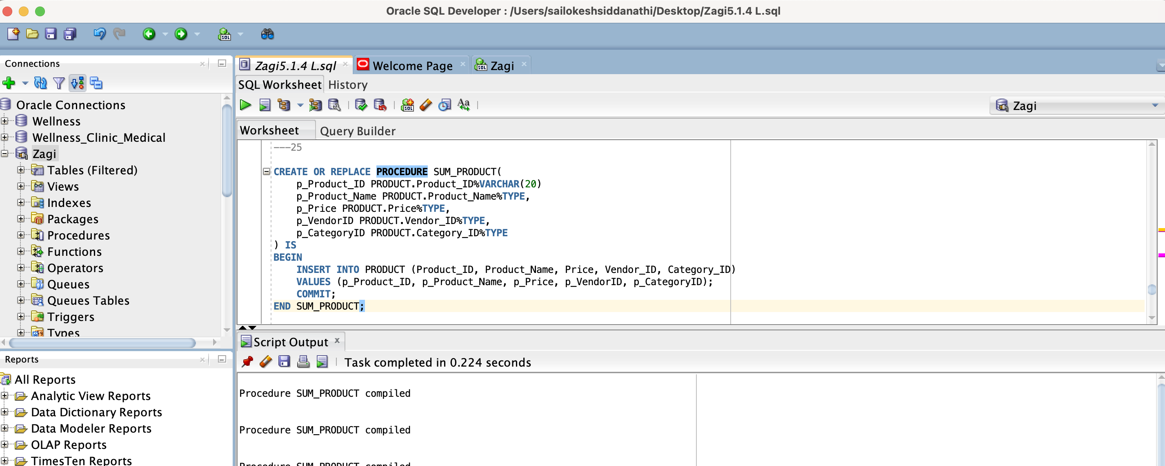

(26) Write a procedure that when called it will increase the price by a percent for a particular product.

CREATE OR REPLACE PROCEDURE Increase_Price (p_Product_ID IN Product.Product_ID%TYPE,p_PercentIncrease IN NUMBER)

AS

BEGIN

UPDATE Product

SET Price = Price * (1 + p_PercentIncrease / 100)

WHERE Product_ID = p_Product_ID;

COMMIT;

END Increase_Price;

/

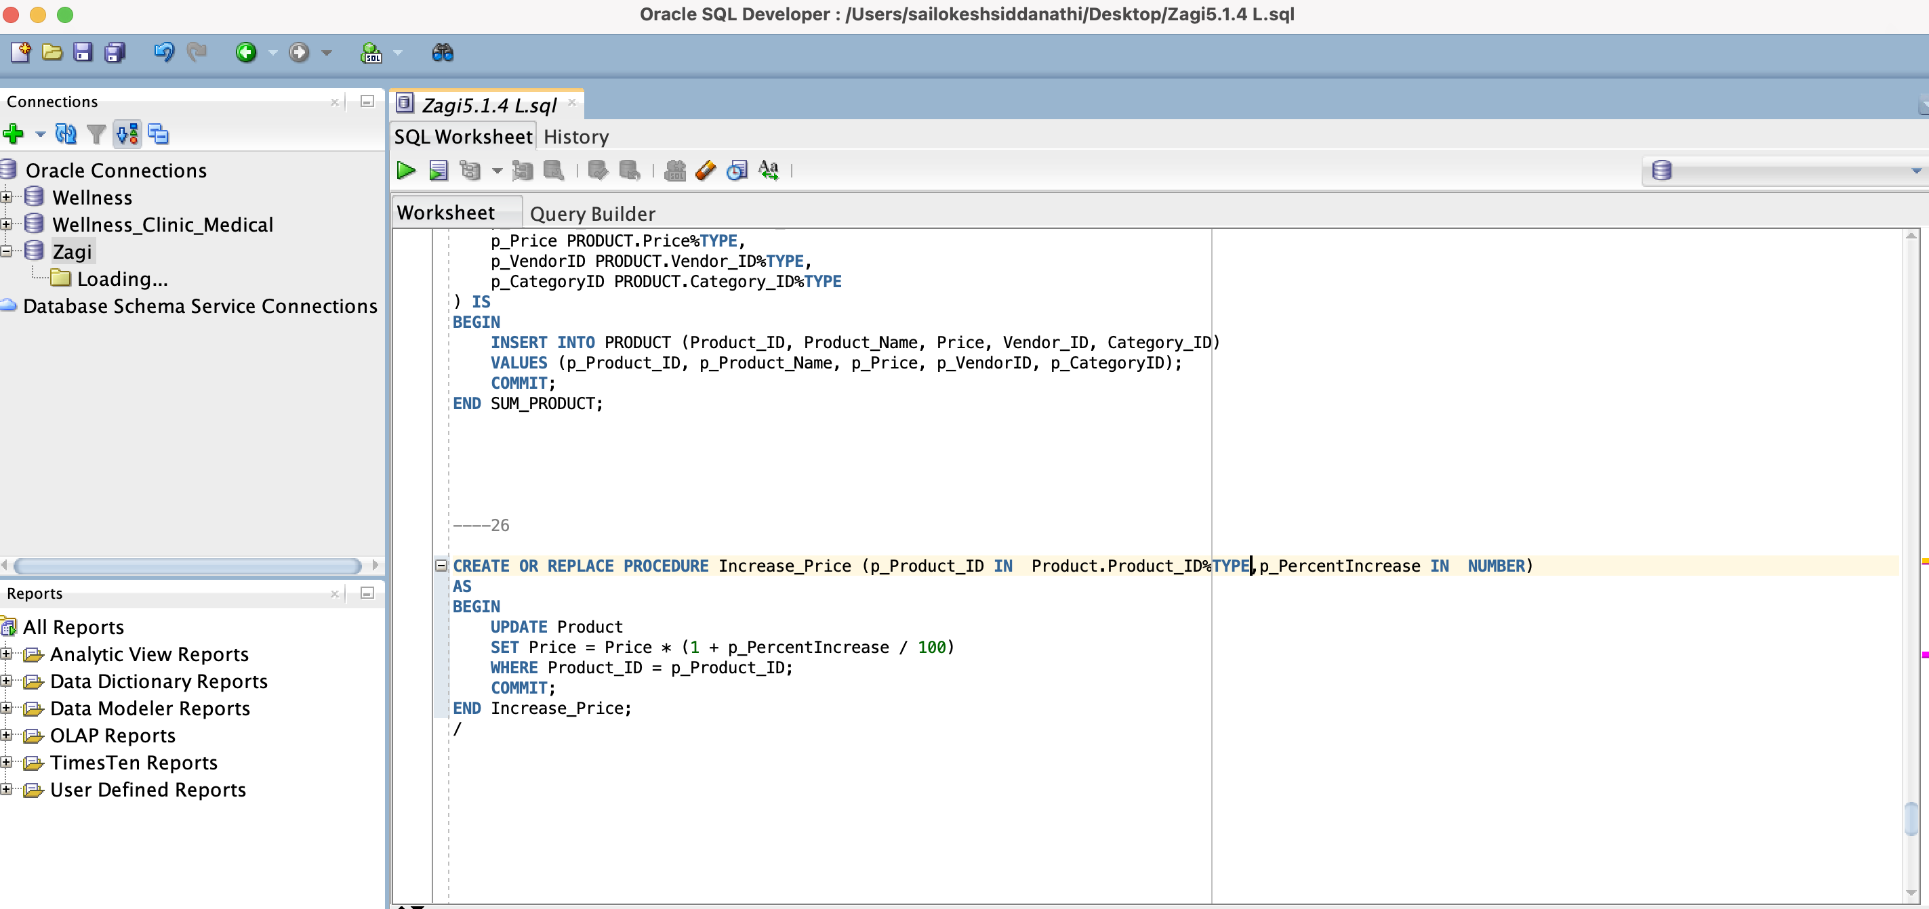

Views

(27) Create a view named products_more_than_3_sold to select the following: For each product that has more than three items sold within all sales transactions, retrieve the product ID, product name, and product price.

CREATE OR REPLACE VIEW products_more_sold3 AS

SELECT

Product.Product_name,

Product.Product_id,

Product.Price

FROM

Product

JOIN

SALES_TRANSACTION_PRODUCT ON Product.Product_ID = SALES_TRANSACTION_PRODUCT.Product_ID

JOIN

SALES_TRANSACTION_PRODUCT ON SALES_TRANSACTION_PRODUCT.Transaction_ID = SALES_TRANSACTION_PRODUCT.Transaction_ID

GROUP BY

Product.Product_ID,

Product.Product_Name,

Product.Price

HAVING

SUM(SALES_TRANSACTION_PRODUCT.Quantity) > 3;

SELECT * FROM products_more_sold3;

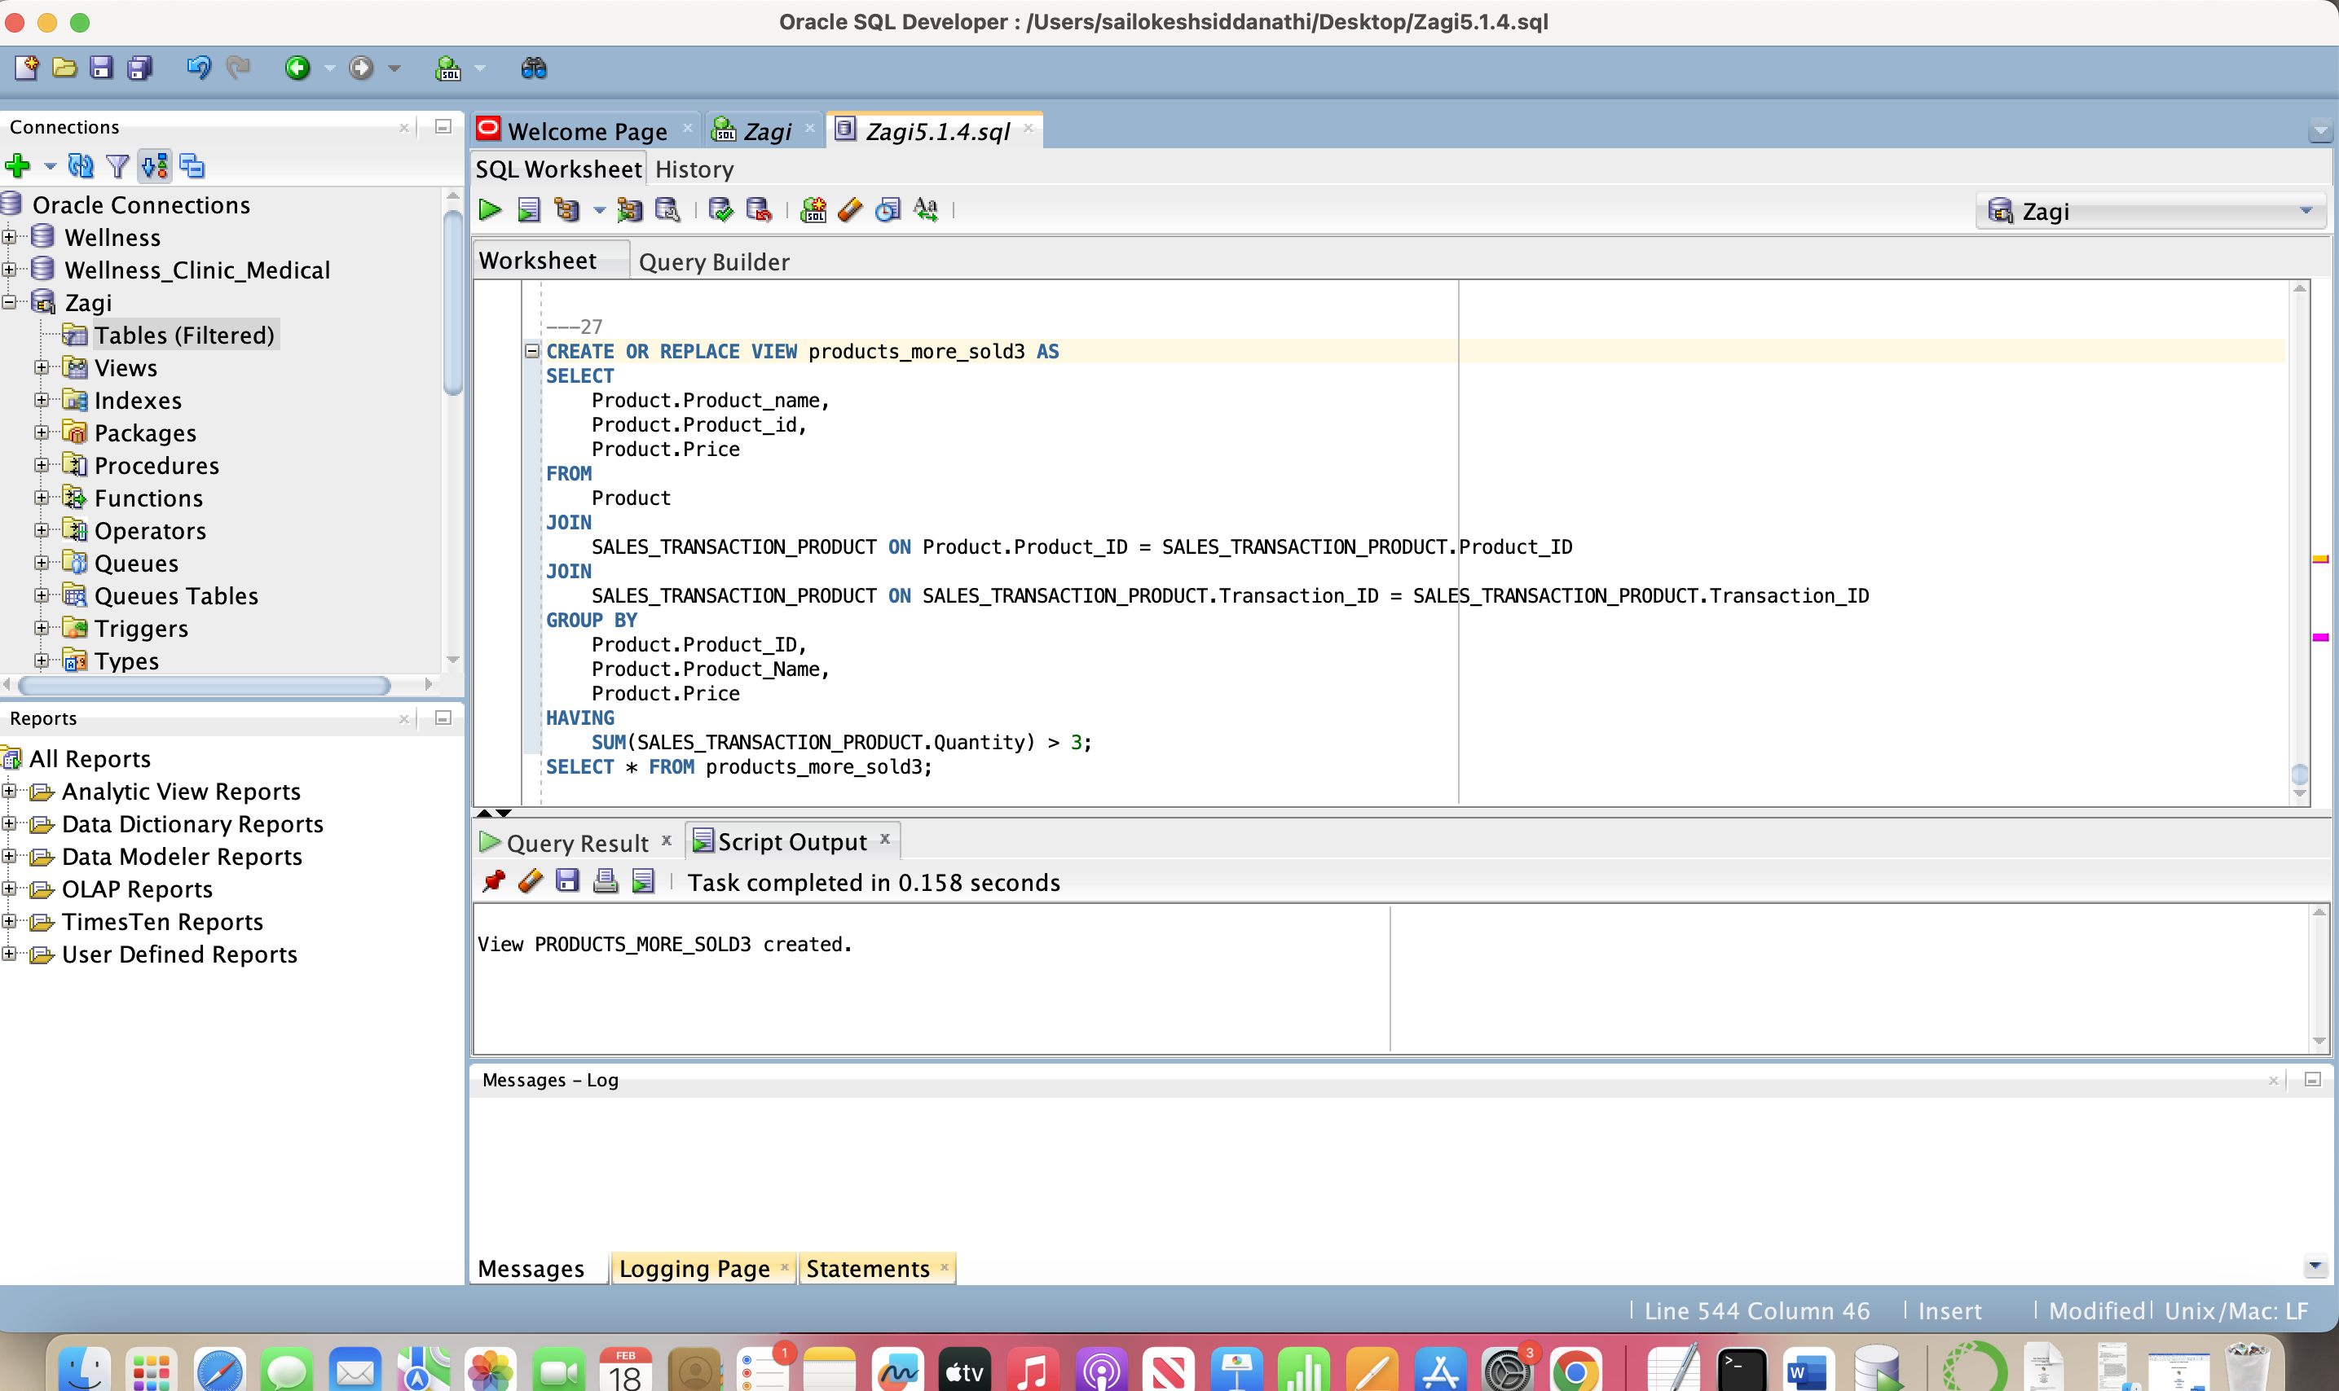

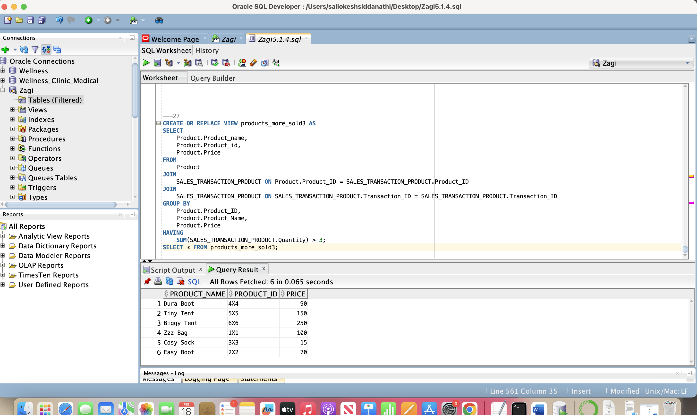

(28) Create a view named products_in_multiple_trnsc to select the following: for each product whose items were sold in more than one transaction, retrieve the product name and product price.

CREATE OR REPLACE VIEW products_in_multiple_trnsc AS

SELECT

Product.Product_Name,

Product.Price

FROM

Product

JOIN

SALES_TRANSACTION_PRODUCT ON Product.Product_ID = SALES_TRANSACTION_PRODUCT.Product_ID

GROUP BY

Product.Product_ID,

Product.Product_Name,

Product.Price

HAVING

COUNT(DISTINCT SALES_TRANSACTION_PRODUCT.Transaction_ID) > 1;

SELECT * FROM products_in_multiple_trnsc

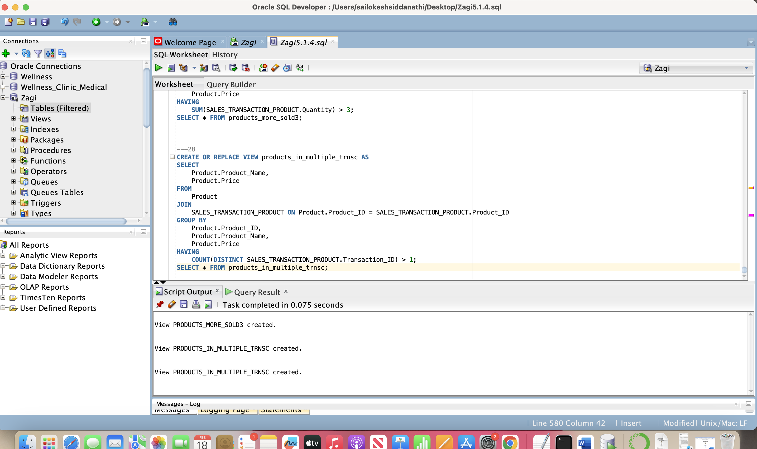

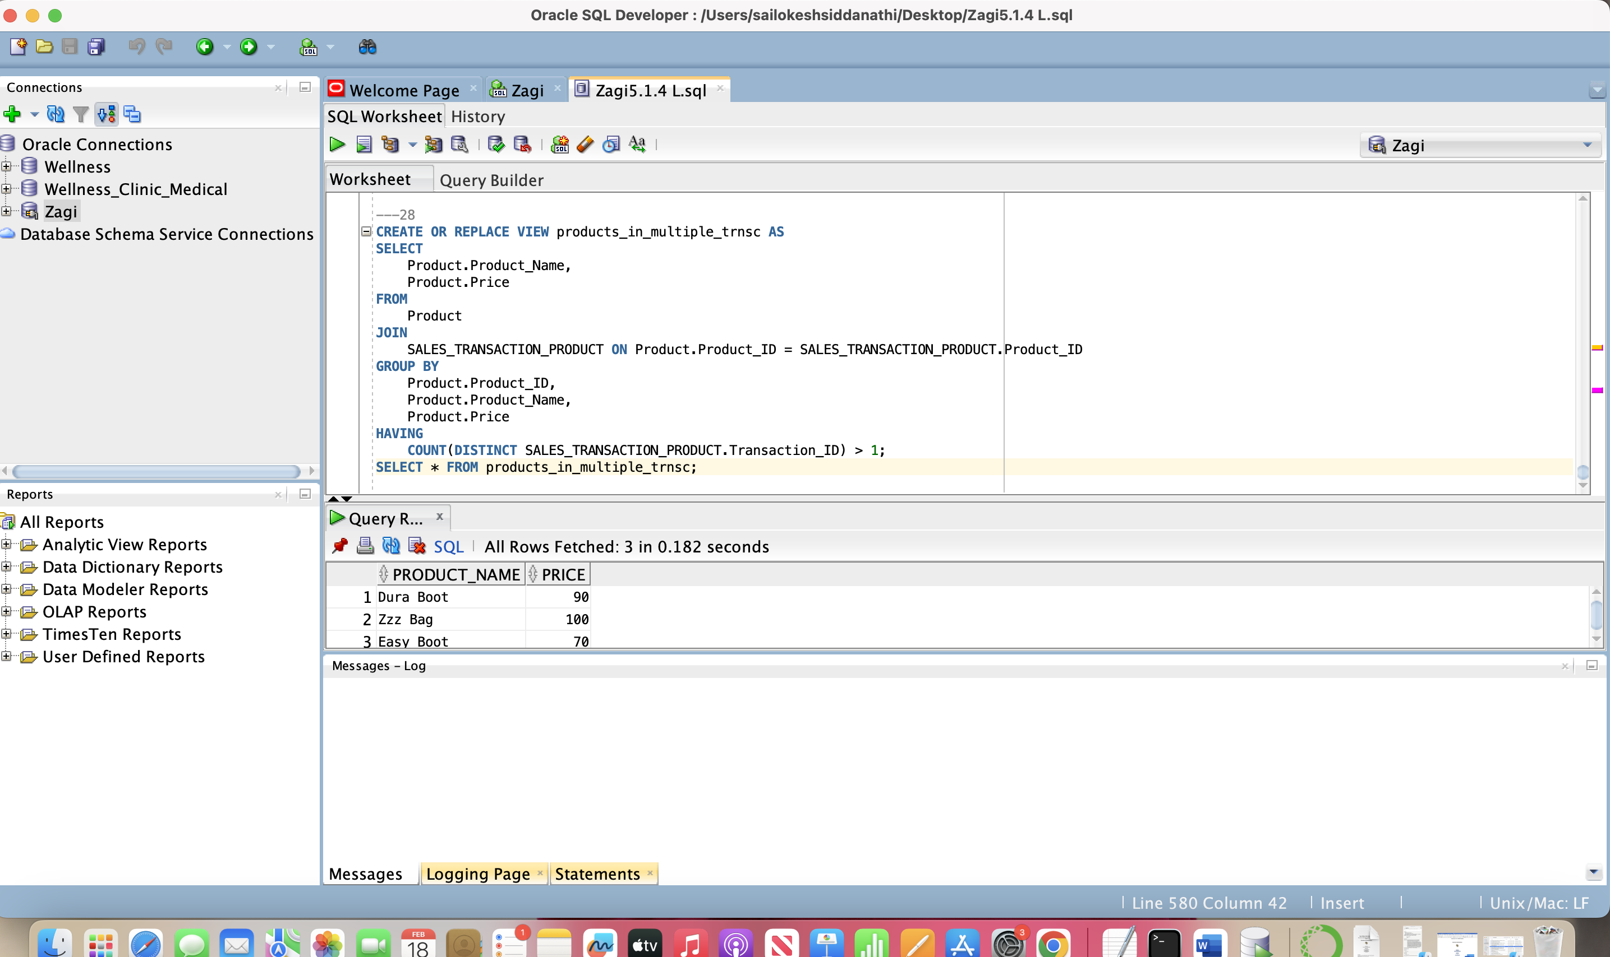

(29) retrieve the product id, product name, and product price for each product that has more than three items sold within all sales transactions OR whose items were sold in more than one sales transaction.

SELECT Product.product_id, Product.product_name, Product.price

FROM Product

JOIN Sales_transaction_product ON Product.product_id = Sales_transaction_product.product_id

GROUP BY Product.product_id, Product.product_name, Product.price

HAVING SUM(Sales_transaction_product.quantity) > 3 OR COUNT(DISTINCT Sales_transaction_product.transaction_id) > 1;

